Name __________________________________ Date ________________
FOOD WEB RESCUE · LEVEL 3: CHALLENGE

Food Web Rescue: Challenge
Use the field notes and diagrams. Diets in this food web are simplified, so base every answer on this food web. Explain your reasoning with evidence.

Part 1: Model the web
1. Field notes: Snails eat algae. Sunfish eat snails. Herons eat sunfish. Muskrats eat cattails. Foxes eat muskrats and rabbits. Squirrels eat acorns. Hawks eat squirrels. Sort each animal by its consumer level in this food web.
Items to sort: Snails Muskrats Squirrels Sunfish Foxes Hawks Herons

Primary consumer | Secondary consumer | Tertiary consumer

2. Field notes: Squirrels and deer eat acorns from oak trees. Hawks eat squirrels. Draw every arrow in the Cedar Hollow Woods food web.
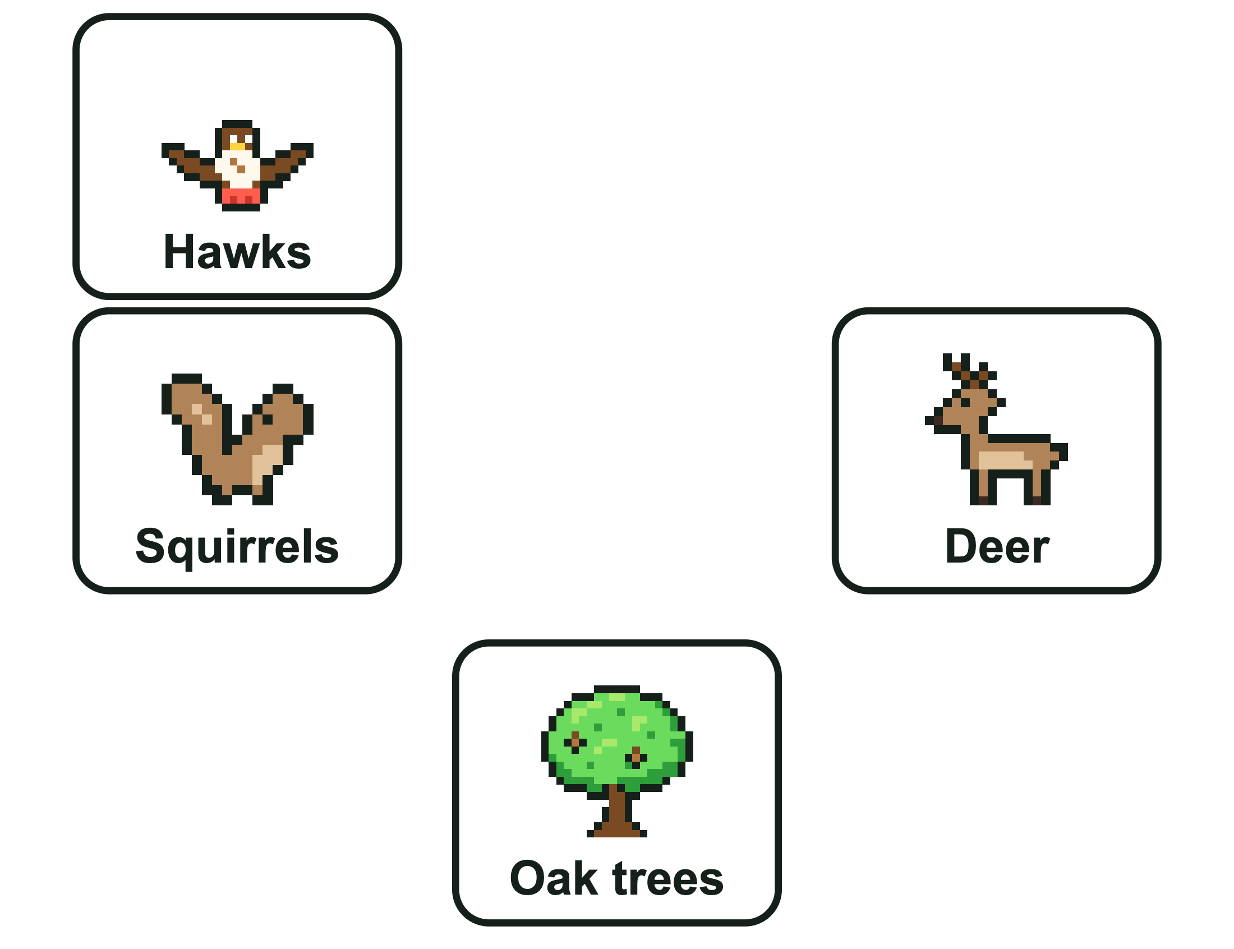

Part 2: Energy and predictions
3. The algae in Cedar Hollow Pond capture 10,000 units of energy. Use the 10 percent rule of thumb for the chain Algae → Snails → Sunfish → Herons. Snails: about ________________ units. Sunfish: about ________________ units. Herons: about ________________ units, which is about ________________ percent of the algae's energy.
4. The 10 percent rule is a rule of thumb. What does that mean, and where does most of the energy go instead of passing up a level?

5. Field notes: Squirrels eat acorns. Hawks eat squirrels. A dry fall means the oak trees drop far fewer acorns. What will most likely happen to the hawks?
A. Hawks increase, because hungry squirrels are easier to catch
B. Hawks decrease, because less energy reaches them through the squirrels
C. Nothing, because hawks never eat acorns
D. Hawks start eating acorns instead
6. Imagine the shelf fungus and every other decomposer in Cedar Hollow Woods disappeared. The dead leaves on the ground would most likely ________________, and the nutrients in the soil would most likely ________________.
7. In this food web, hawks do not eat acorns, so losing the hawks could not change the number of acorns.
True False
Circle one.
8. Owls move into Cedar Hollow Woods and hunt squirrels. Make a claim about how the squirrel population would most likely change, with evidence from this food web. Then name one other population that could be affected, and explain why.

FOOD WEB RESCUE · LEVEL 3: CHALLENGE

Answer Key
Food Web Rescue: Challenge

Part 1: Model the web
1. Field notes: Snails eat algae. Sunfish eat snails. Herons eat sunfish. Muskrats eat cattails. Foxes eat muskrats and rabbits. Squirrels eat acorns. Hawks eat squirrels. Sort each animal by its consumer level in this food web.
Primary consumer | Secondary consumer | Tertiary consumer
Snails | Sunfish | Herons
Muskrats | Foxes
Squirrels | Hawks
Snails, muskrats, and squirrels eat producers. Sunfish, foxes, and hawks eat primary consumers. Herons eat sunfish, which are secondary consumers.
2. Field notes: Squirrels and deer eat acorns from oak trees. Hawks eat squirrels. Draw every arrow in the Cedar Hollow Woods food web.
Look for: Three arrows: Oak trees → Squirrels, Oak trees → Deer, Squirrels → Hawks.
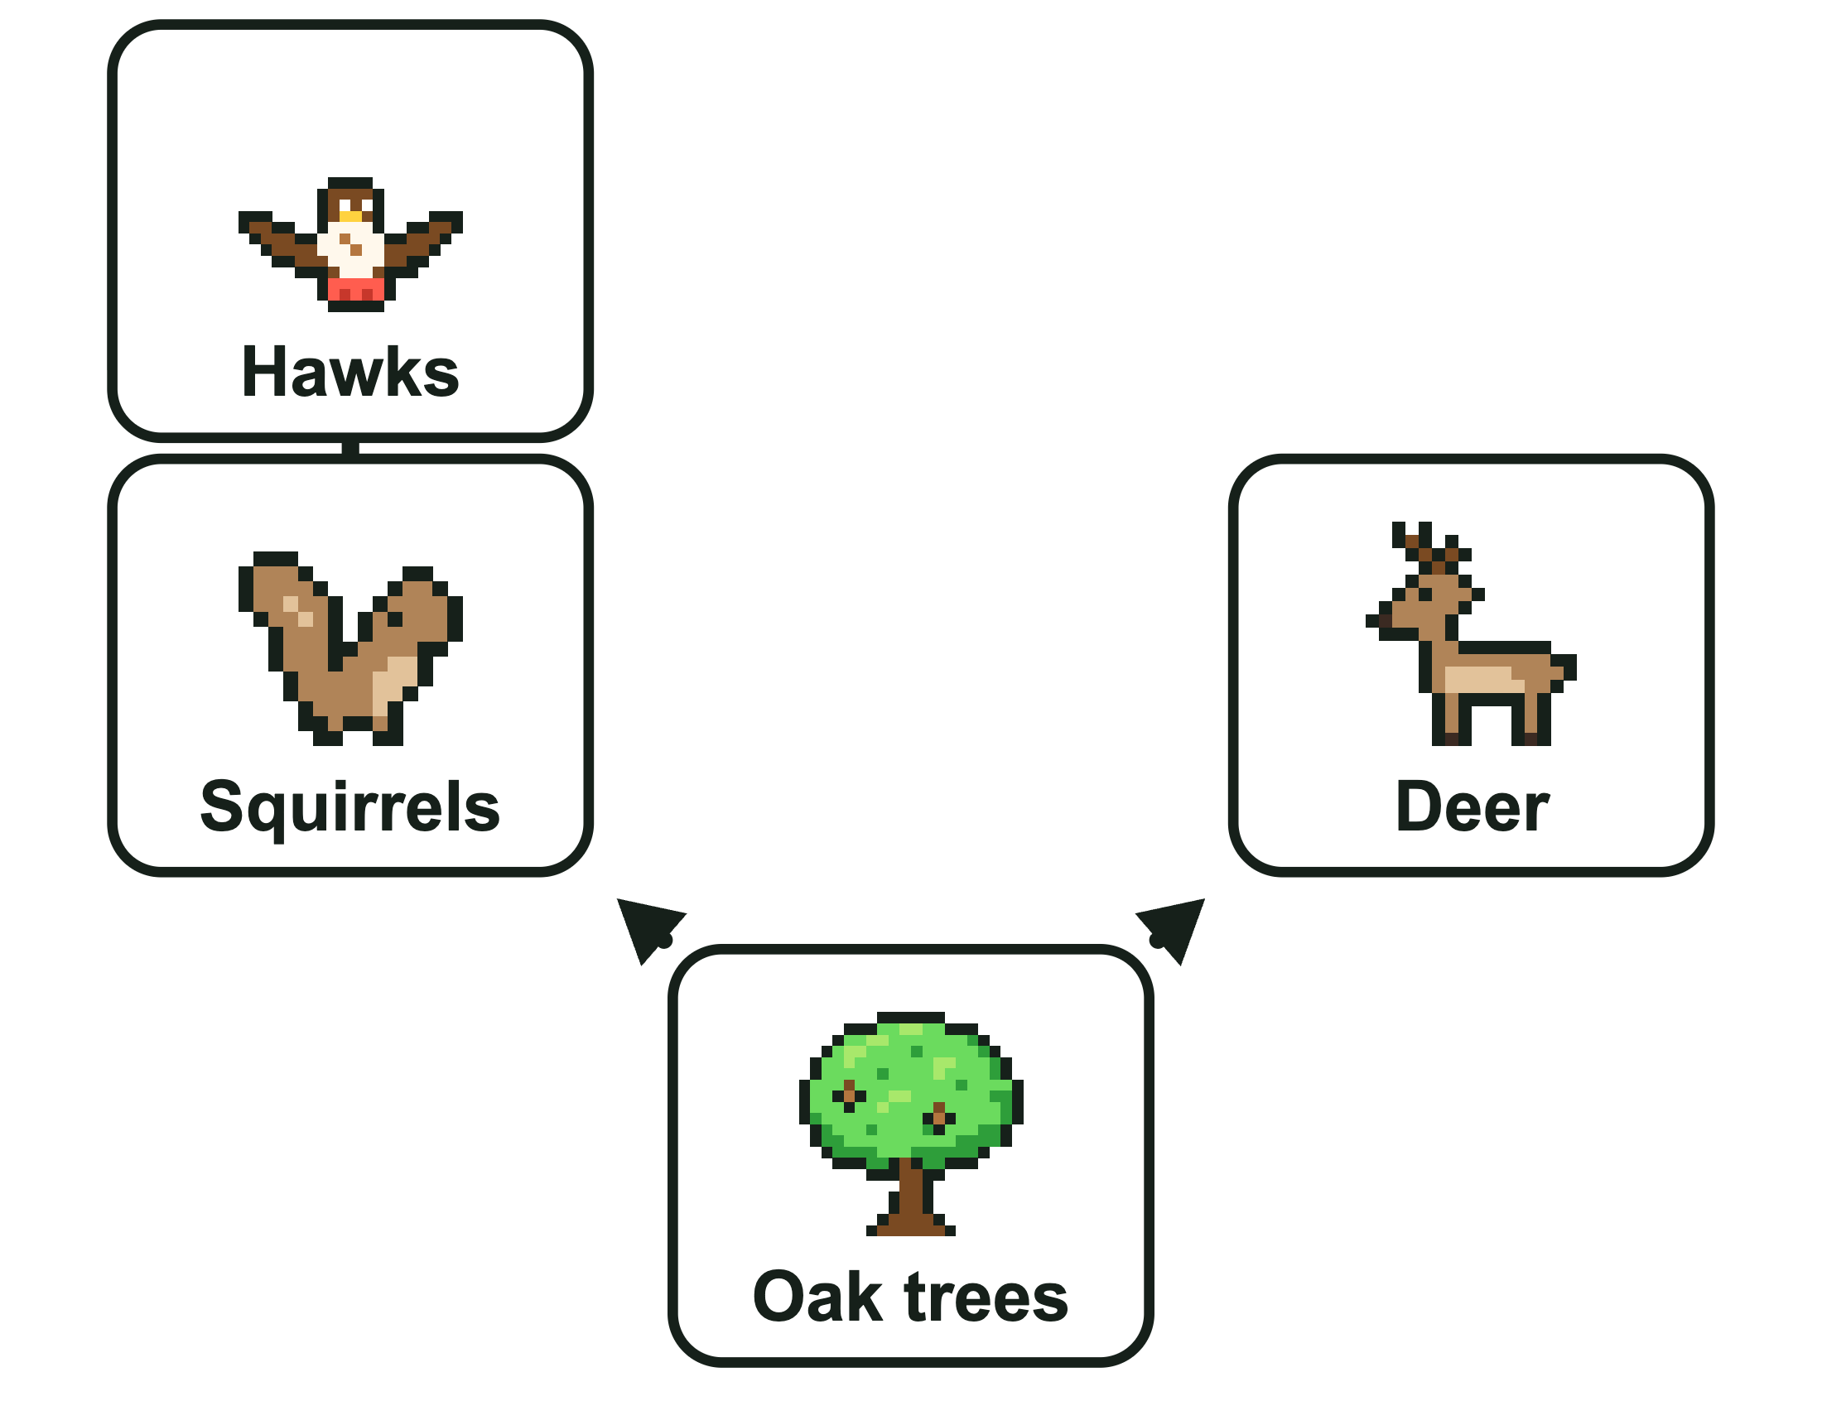

Part 2: Energy and predictions
3. The algae in Cedar Hollow Pond capture 10,000 units of energy. Use the 10 percent rule of thumb for the chain Algae → Snails → Sunfish → Herons. Snails: about ____ units. Sunfish: about ____ units. Herons: about ____ units, which is about ____ percent of the algae's energy.
The algae in Cedar Hollow Pond capture 10,000 units of energy. Use the 10 percent rule of thumb for the chain Algae → Snails → Sunfish → Herons. Snails: about 1,000 units. Sunfish: about 100 units. Herons: about 10 units, which is about 0.1 percent of the algae's energy.
Each step keeps about 10 percent. Three steps: 10 percent of 10 percent of 10 percent is 0.1 percent (10 out of 10,000).
4. The 10 percent rule is a rule of thumb. What does that mean, and where does most of the energy go instead of passing up a level?
Sample answer: It is an approximation: the real amount varies, but only a small part passes up. Most of the energy is used to move, grow, and stay alive, and much of it is given off as heat. Some is in parts that are never eaten.
5. Field notes: Squirrels eat acorns. Hawks eat squirrels. A dry fall means the oak trees drop far fewer acorns. What will most likely happen to the hawks?
B. Hawks decrease, because less energy reaches them through the squirrels
Fewer acorns means fewer squirrels, and hawks eat only squirrels in this web. A change two steps down the chain reaches the hawks.
6. Imagine the shelf fungus and every other decomposer in Cedar Hollow Woods disappeared. The dead leaves on the ground would most likely ____, and the nutrients in the soil would most likely ____.
Imagine the shelf fungus and every other decomposer in Cedar Hollow Woods disappeared. The dead leaves on the ground would most likely increase, and the nutrients in the soil would most likely decrease.
Without decomposers, dead leaves are not broken down, so they pile up. The nutrients stay locked in the dead leaves, so fewer reach the soil, and the oak trees most likely grow less.
7. In this food web, hawks do not eat acorns, so losing the hawks could not change the number of acorns.
False
Hawks eat squirrels. Without hawks, the squirrel population most likely grows, and more squirrels eat more acorns, so the acorns most likely decrease.
8. Owls move into Cedar Hollow Woods and hunt squirrels. Make a claim about how the squirrel population would most likely change, with evidence from this food web. Then name one other population that could be affected, and explain why.
Sample answer: Claim: the squirrel population would most likely decrease. Evidence: hawks already eat squirrels, and now owls eat them too, so more squirrels are eaten. Other effect (any one): hawks now compete with the owls for squirrels and could have less food; or the acorns could increase because fewer squirrels are eating them.

