Name __________________________________ Date ________________
FOOD WEB RESCUE · LEVEL 2: ON LEVEL

Food Web Rescue: On Level Practice
Use the field notes and pictures. Arrows point from the food to the eater. Answer for this food web, and explain in complete sentences.

Part 1: Roles in the web
1. Read the field notes. Sort each living thing by its role in the Cedar Hollow food webs.
Items to sort: Grass Rabbits: eat grass Snails: eat algae Foxes: eat muskrats and rabbits Sunfish: eat snails Shelf fungus: breaks down dead logs

Producer | Primary consumer | Secondary consumer | Decomposer

2. In the chain Algae → Snails → Sunfish → Herons, the snails are the ________________ consumers and the herons are the ________________ consumers.
3. Decomposers such as bacteria and fungi return nutrients to the soil and water so producers can use them again.
True False
Circle one.

Part 2: Energy and arrows
4. Cedar Hollow Pond has thousands of snails but only a few herons. Use the idea of an energy pyramid to explain why.

5. The algae in Cedar Hollow Pond capture 10,000 units of energy. Using the 10 percent rule of thumb, the snails get about ________________ units and the sunfish get about ________________ units.
6. Field notes: Muskrats eat cattails. Rabbits eat grass. Foxes eat muskrats and rabbits. Draw all four arrows for the Marsh Meadow food web.
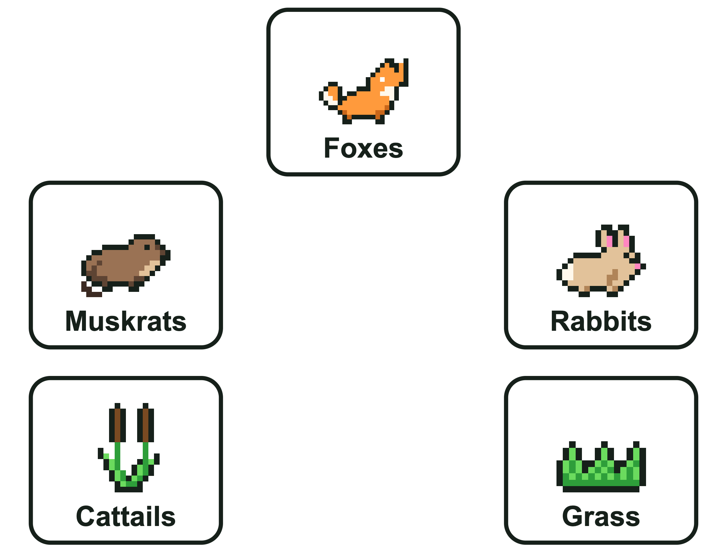

Part 3: Predict changes
7. Field notes: Foxes eat muskrats and rabbits. A second fox family moves into the meadow. Which population would most likely decrease at first?
A. Grass B. Rabbits C. Cattails D. Mushrooms
8. Field notes: Herons eat sunfish. Sunfish eat snails. If the herons left Cedar Hollow Pond, predict what would most likely happen first to the sunfish, and later to the snails. Explain using the arrows.

FOOD WEB RESCUE · LEVEL 2: ON LEVEL

Answer Key
Food Web Rescue: On Level Practice

Part 1: Roles in the web
1. Read the field notes. Sort each living thing by its role in the Cedar Hollow food webs.
Producer | Primary consumer | Secondary consumer | Decomposer
Grass | Rabbits: eat grass | Foxes: eat muskrats and rabbits | Shelf fungus: breaks down dead logs
 | Snails: eat algae | Sunfish: eat snails
Rabbits and snails eat producers. Foxes and sunfish eat primary consumers. Shelf fungus breaks down dead things.
2. In the chain Algae → Snails → Sunfish → Herons, the snails are the ____ consumers and the herons are the ____ consumers.
In the chain Algae → Snails → Sunfish → Herons, the snails are the primary consumers and the herons are the tertiary consumers.
The snails eat the producer (algae). The herons are three feeding steps above the algae.
3. Decomposers such as bacteria and fungi return nutrients to the soil and water so producers can use them again.
True

Part 2: Energy and arrows
4. Cedar Hollow Pond has thousands of snails but only a few herons. Use the idea of an energy pyramid to explain why.
Sample answer: Only about 10 percent of the energy passes up each level, so much less energy reaches the top of the food web. There is only enough energy to support a few top predators like herons.
5. The algae in Cedar Hollow Pond capture 10,000 units of energy. Using the 10 percent rule of thumb, the snails get about ____ units and the sunfish get about ____ units.
The algae in Cedar Hollow Pond capture 10,000 units of energy. Using the 10 percent rule of thumb, the snails get about 1,000 units and the sunfish get about 100 units.
Each level gets about 10 percent of the level below: 10 percent of 10,000 is about 1,000, and 10 percent of 1,000 is about 100.
6. Field notes: Muskrats eat cattails. Rabbits eat grass. Foxes eat muskrats and rabbits. Draw all four arrows for the Marsh Meadow food web.
Look for: Cattails → Muskrats, Grass → Rabbits, Muskrats → Foxes, Rabbits → Foxes. Every arrow points toward the eater.
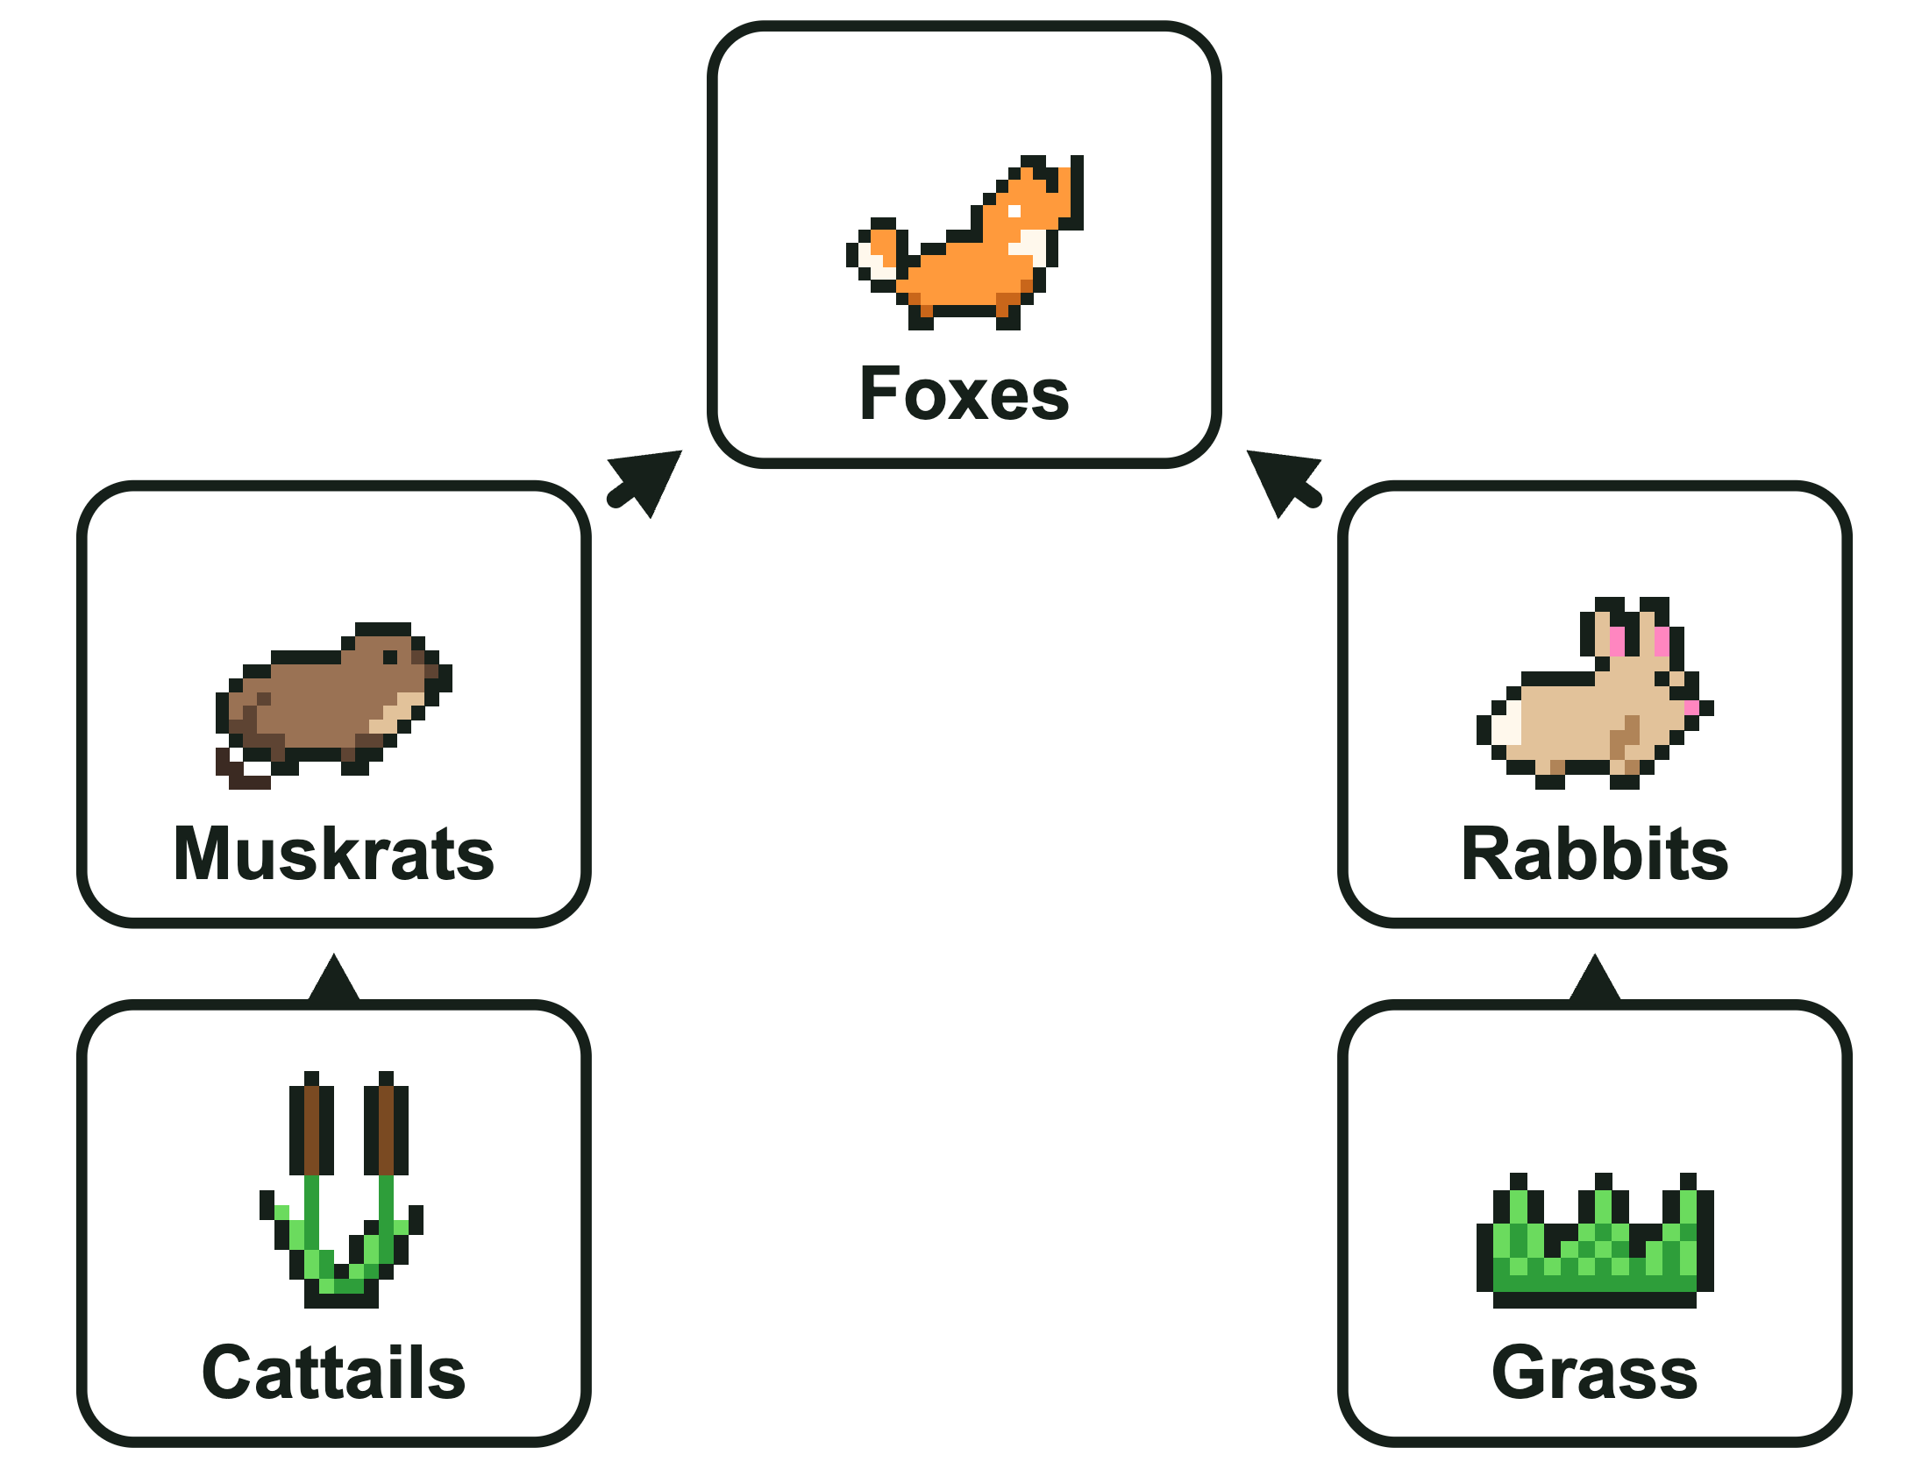

Part 3: Predict changes
7. Field notes: Foxes eat muskrats and rabbits. A second fox family moves into the meadow. Which population would most likely decrease at first?
B. Rabbits
More foxes hunt more rabbits, so the rabbits most likely decrease. Grass and cattails are not eaten by foxes, and mushrooms are decomposers.
8. Field notes: Herons eat sunfish. Sunfish eat snails. If the herons left Cedar Hollow Pond, predict what would most likely happen first to the sunfish, and later to the snails. Explain using the arrows.
Sample answer: The sunfish would most likely increase at first, because in this food web herons are the only animals that eat them (the Sunfish → Herons arrow is gone). Later, more sunfish would eat more snails (Snails → Sunfish), so the snails would most likely decrease.

