Name __________________________________ Date ________________
FOOD WEB RESCUE · LEVEL 1: SUPPORT

Food Web Rescue: Support Practice
Use the pictures and word banks. Remember: in a food web, arrows point from the food to the eater. That is the way energy flows.

Part 1: Jobs in the preserve
1. Sort each living thing from Cedar Hollow Preserve by its job.
Items to sort: Algae Cattails Snails Foxes Pond bacteria Mushrooms

Producer | Consumer | Decomposer

2. The marsh needs a producer. Which living thing should the ranger release?
A. Cattails B. Muskrats C. Mushrooms
3. Mushrooms are producers because they grow out of the ground.
True False
Circle one.

Part 2: Follow the energy
4. What does this arrow show?
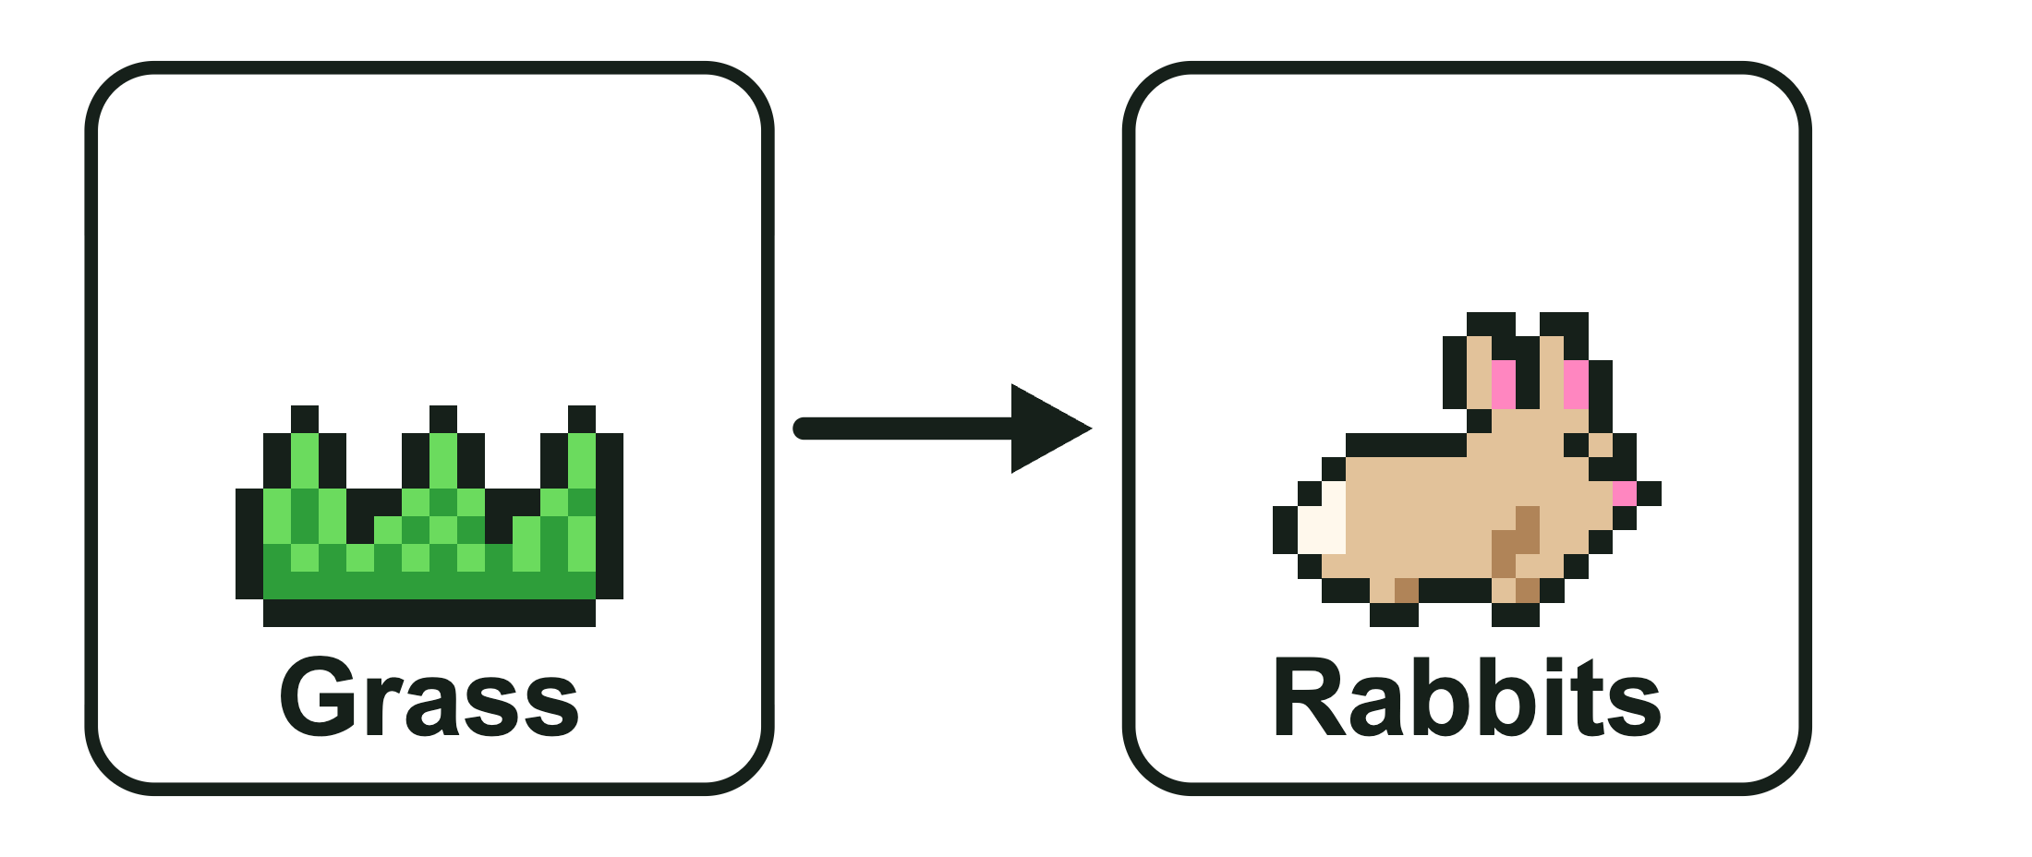
A. The grass eats the rabbits
B. The rabbits give energy to the grass
C. Energy moves from the grass to the rabbits when the rabbits eat it
5. Snails eat algae. Sunfish eat snails. Herons eat sunfish. Draw an arrow between each pair to show which way the energy flows.
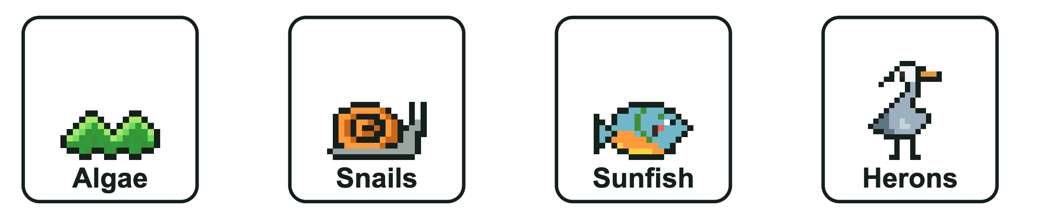
6. This energy pyramid shows the Cedar Hollow Pond food chain. Which level has the most energy?
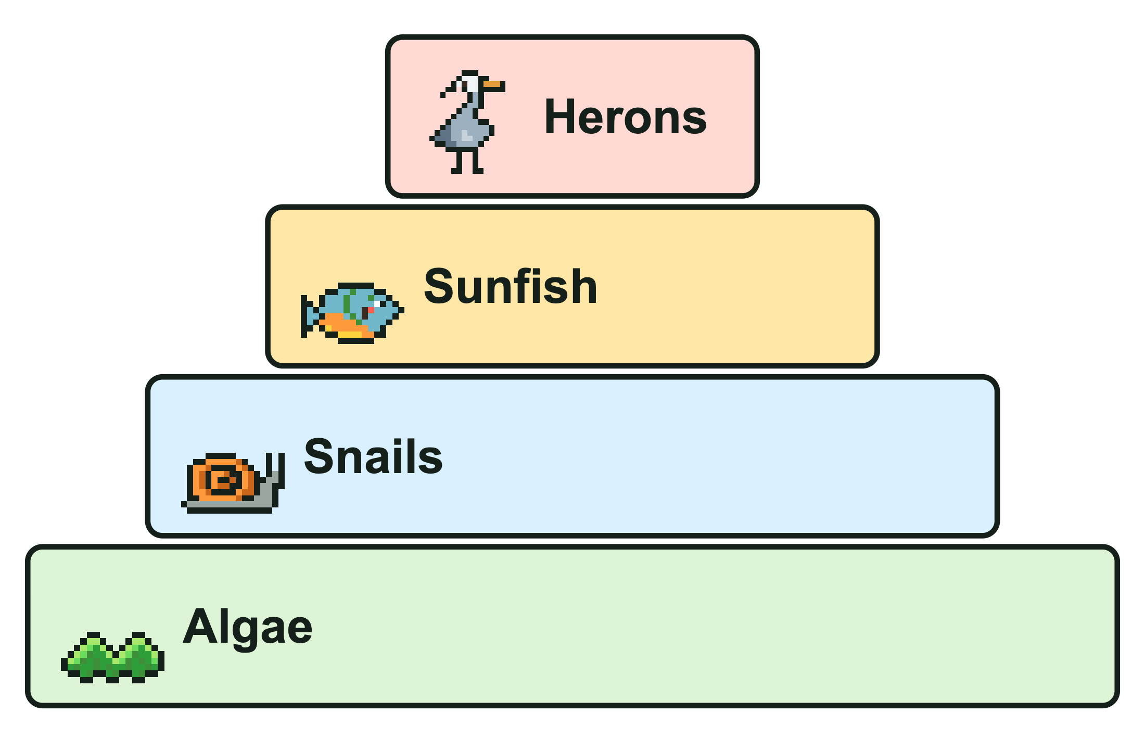
A. Herons B. Sunfish C. Snails D. Algae

Part 3: Run the season
7. In the pond, sunfish are the only animals that eat snails. If a sickness killed most of the sunfish, the number of snails would most likely go ________________ at first. Then the snails would eat more ________________, so the amount of algae would most likely go ________________.
Word bank: up down algae cattails

FOOD WEB RESCUE · LEVEL 1: SUPPORT

Answer Key
Food Web Rescue: Support Practice

Part 1: Jobs in the preserve
1. Sort each living thing from Cedar Hollow Preserve by its job.
Producer | Consumer | Decomposer
Algae | Snails | Pond bacteria
Cattails | Foxes | Mushrooms
Algae and cattails make food from sunlight. Snails and foxes eat other living things. Pond bacteria and mushrooms break down dead things.
2. The marsh needs a producer. Which living thing should the ranger release?
A. Cattails
Cattails make their own food from sunlight. Muskrats are consumers, and mushrooms are decomposers.
3. Mushrooms are producers because they grow out of the ground.
False
Mushrooms are decomposers. They cannot make food from sunlight, so they get energy by breaking down dead things.

Part 2: Follow the energy
4. What does this arrow show?
C. Energy moves from the grass to the rabbits when the rabbits eat it
5. Snails eat algae. Sunfish eat snails. Herons eat sunfish. Draw an arrow between each pair to show which way the energy flows.
Look for: Three arrows, each pointing toward the eater: Algae → Snails, Snails → Sunfish, Sunfish → Herons.
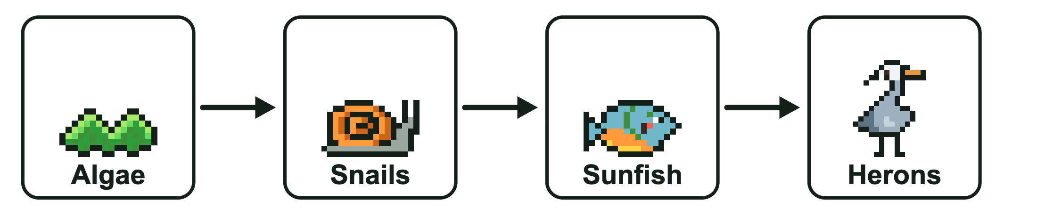
6. This energy pyramid shows the Cedar Hollow Pond food chain. Which level has the most energy?
D. Algae
The producers at the bottom have the most energy. Each level up gets only about 10 percent of the level below.

Part 3: Run the season
7. In the pond, sunfish are the only animals that eat snails. If a sickness killed most of the sunfish, the number of snails would most likely go ____ at first. Then the snails would eat more ____, so the amount of algae would most likely go ____.
In the pond, sunfish are the only animals that eat snails. If a sickness killed most of the sunfish, the number of snails would most likely go up at first. Then the snails would eat more algae, so the amount of algae would most likely go down.
With fewer sunfish eating them, more snails survive. Snails eat algae, so more snails means less algae later.

