Name __________________________________ Date ________________
CEDAR HOLLOW SLICE SHOP · LEVEL 2: ON LEVEL

Slice Shop: Equivalent Orders
Equivalent fractions name the same amount. Use the pies, or multiply the numerator and the denominator by the same number. Red slices are served. Show your thinking.

Part 1: Serve with smaller slices
1. Zoe wants 2/3 of a blueberry pie. Today the same-size pies are cut into 6 slices. How many slices do you serve?
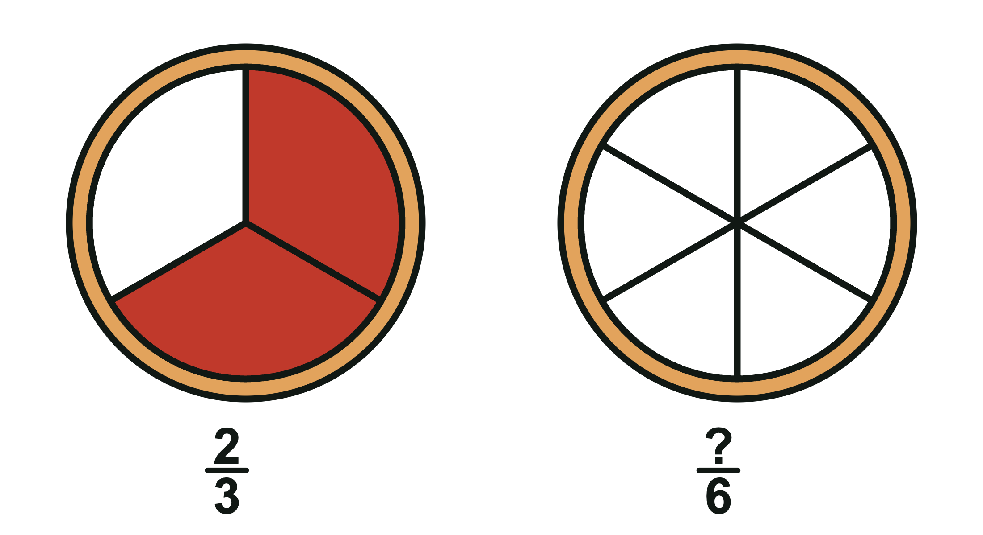
A. 4 B. 2 C. 3 D. 6
2. Ana wants 3/4 of a pie. The first pie shows 3/4. Shade the second pie to show the same amount. Then write the fraction in eighths.
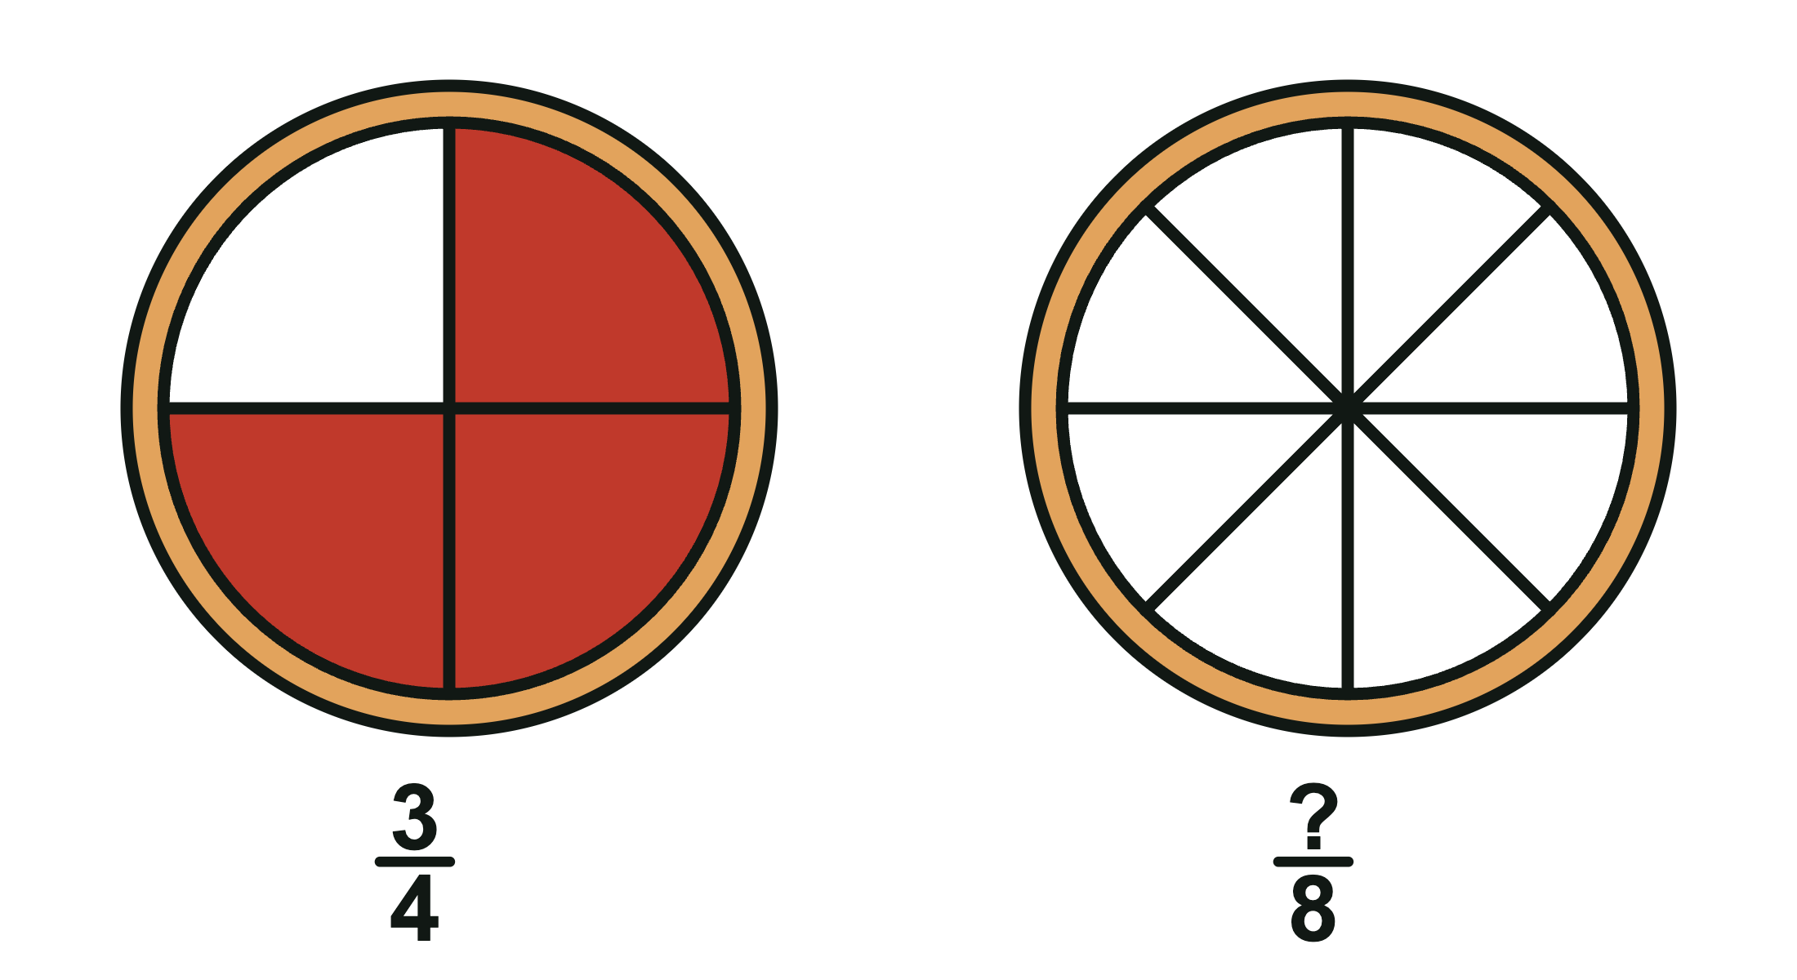
3. Fill in the missing numbers: 1/2 = ________________/10, 3/4 = 9/________________, and 2/3 = ________________/12.
4. Kai ordered 1/3 of a pie. Which amount is not the same as 1/3 of a pie?
A. 2/6 B. 3/6 C. 4/12
5. 2/3 = 3/4, because you add 1 to the top and 1 to the bottom.
True False
Circle one.

Part 2: Compare orders
6. Leo ordered 3/4 of a pie. Zoe ordered 5/8 of a same-size pie. Who gets the bigger box?
A. Zoe B. Same size boxes C. Leo
7. Sort each order into the box with the fraction it is equal to.
Items to sort: 2/4 5/10 2/8 3/12 4/6 8/12

1/2 | 1/4 | 2/3

Part 3: Label the box
8. Sam's box has 1/6 of the apple pie and 2/6 of the cherry pie. Which label goes on the box?
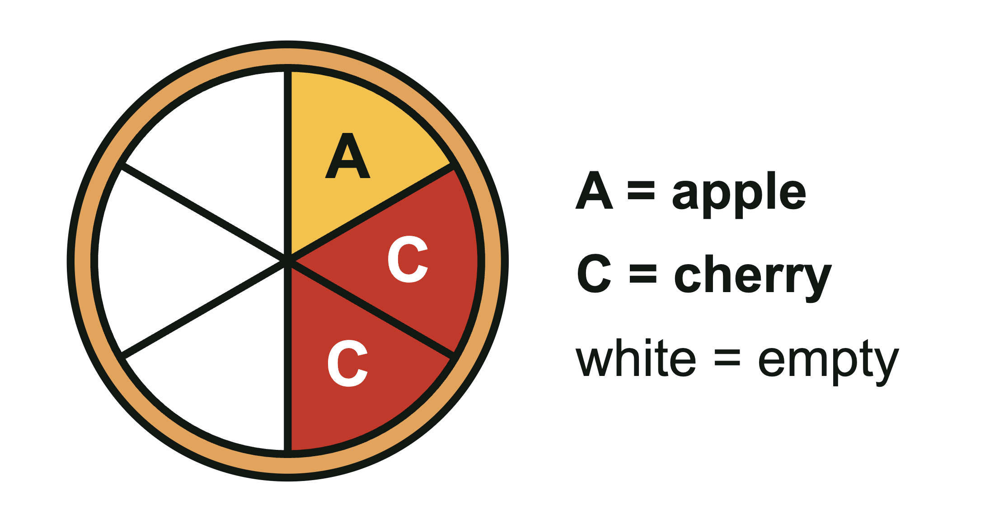
A. 3/12 B. 3/6 C. 2/6
9. Write the label for each box: 2/8 + 3/8 = ________________ and 1/4 + 2/4 = ________________.
10. Ana ordered 4/8 of a pie. Mr. Okafor ordered 1/2 of a same-size pie. Ana says she gets more pie because 4 is more than 1. Is she right? Explain with a model or numbers.

CEDAR HOLLOW SLICE SHOP · LEVEL 2: ON LEVEL

Answer Key
Slice Shop: Equivalent Orders

Part 1: Serve with smaller slices
1. Zoe wants 2/3 of a blueberry pie. Today the same-size pies are cut into 6 slices. How many slices do you serve?
A. 4
Each third is 2 sixths, so 2/3 = 4/6. Also, 2 times 2 = 4 and 3 times 2 = 6.
2. Ana wants 3/4 of a pie. The first pie shows 3/4. Shade the second pie to show the same amount. Then write the fraction in eighths.
Look for: 6 of the 8 slices are shaded. So 3/4 = 6/8.
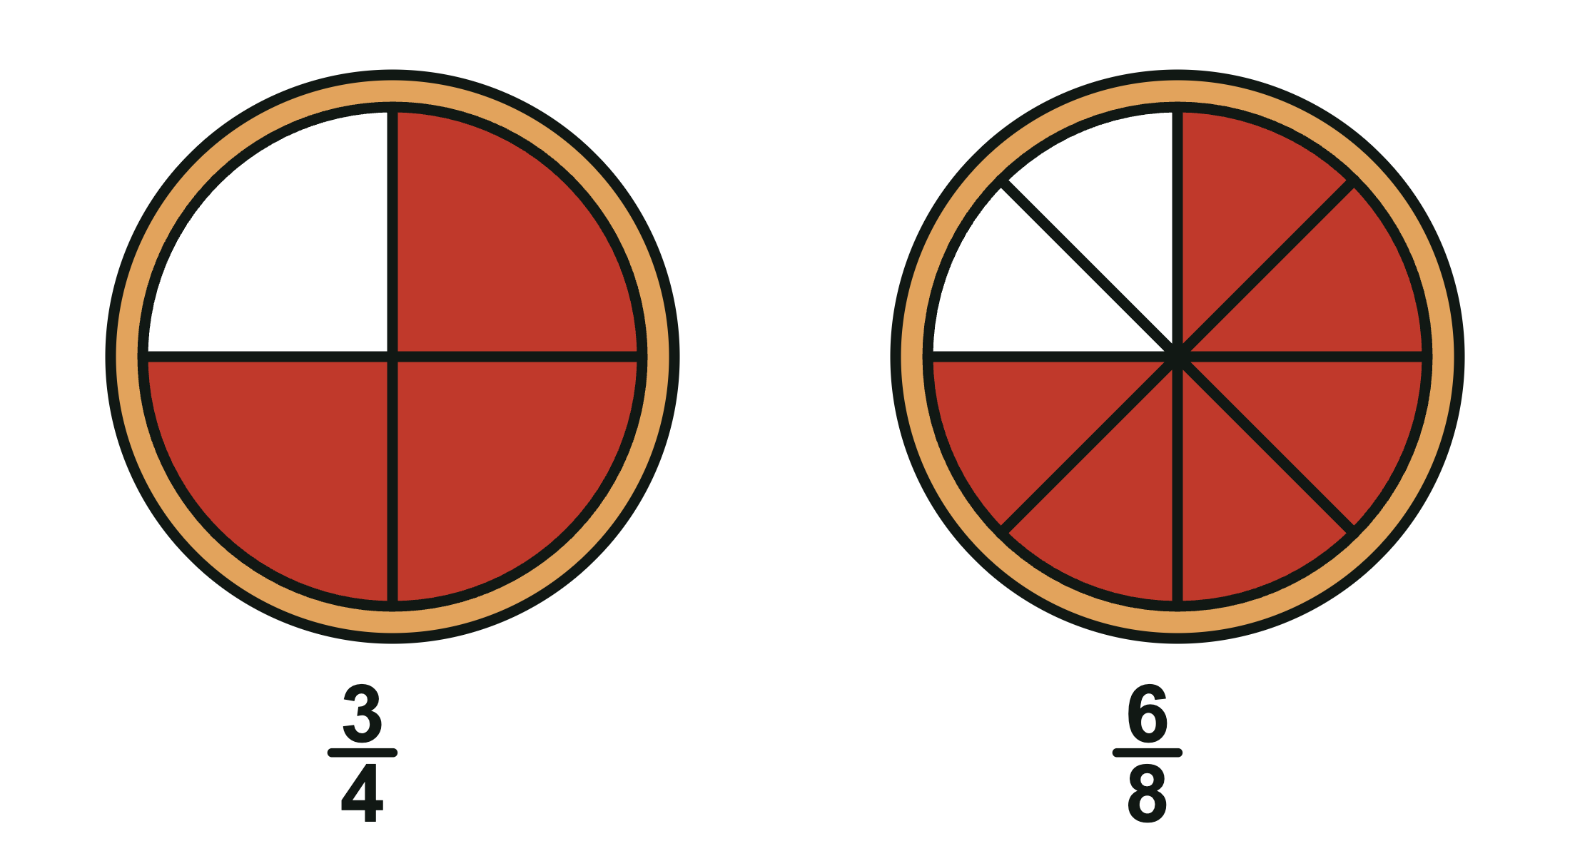
3. Fill in the missing numbers: 1/2 = ____/10, 3/4 = 9/____, and 2/3 = ____/12.
Fill in the missing numbers: 1/2 = 5/10, 3/4 = 9/12, and 2/3 = 8/12.
1 times 5 = 5 and 2 times 5 = 10. 3 times 3 = 9, so 4 times 3 = 12. 2 times 4 = 8 and 3 times 4 = 12.
4. Kai ordered 1/3 of a pie. Which amount is not the same as 1/3 of a pie?
B. 3/6
2/6 and 4/12 equal 1/3. 3/6 equals 1/2, because 3 is half of 6.
5. 2/3 = 3/4, because you add 1 to the top and 1 to the bottom.
False
Adding the same number does not make an equivalent fraction. 2/3 = 8/12 and 3/4 = 9/12, so they are not equal.

Part 2: Compare orders
6. Leo ordered 3/4 of a pie. Zoe ordered 5/8 of a same-size pie. Who gets the bigger box?
C. Leo
3/4 = 6/8, and 6/8 > 5/8. So Leo ordered more pie.
7. Sort each order into the box with the fraction it is equal to.
1/2 | 1/4 | 2/3
2/4 | 2/8 | 4/6
5/10 | 3/12 | 8/12

Part 3: Label the box
8. Sam's box has 1/6 of the apple pie and 2/6 of the cherry pie. Which label goes on the box?
B. 3/6
1/6 + 2/6 = 3/6. Add the top numbers. The slices are still sixths, so the bottom number stays 6. 3/12 adds the bottom numbers too.
9. Write the label for each box: 2/8 + 3/8 = ____ and 1/4 + 2/4 = ____.
Write the label for each box: 2/8 + 3/8 = 5/8 and 1/4 + 2/4 = 3/4.
Add the top numbers and keep the bottom number.
10. Ana ordered 4/8 of a pie. Mr. Okafor ordered 1/2 of a same-size pie. Ana says she gets more pie because 4 is more than 1. Is she right? Explain with a model or numbers.
Sample answer: No. They ordered the same amount. 1/2 = 4/8 (multiply the top and bottom by 4). Eighths are smaller slices than halves, so it takes 4 eighths to make the same half.

