Name __________________________________ Date ________________
CEDAR HOLLOW SLICE SHOP · LEVEL 1: SUPPORT

Slice Shop: Fair Cuts and Orders
Count all the equal slices first. That number is the denominator (the bottom number). Red slices are served. Use the word bank when you see one.

Part 1: Fair cuts
1. The pies are the same size. Which pie is cut into fourths?
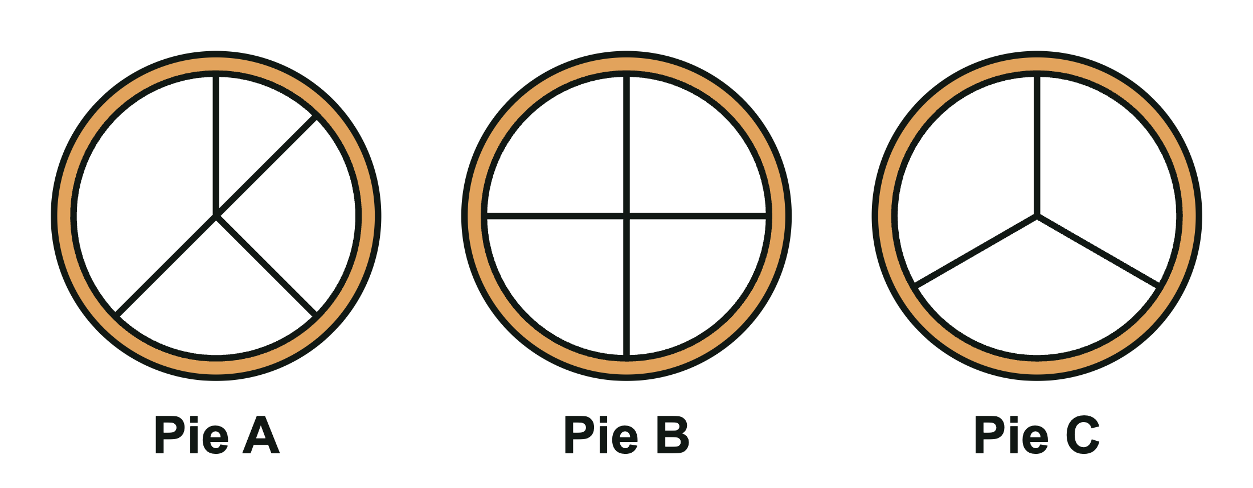
A. Pie A B. Pie B C. Pie C
2. Grandpa Lou asked for thirds. This pie is cut into thirds.

True False
Circle one.

Part 2: Serve the order
3. Ava wants 3/4 of a cherry pie. The pie is cut into 4 equal slices. How many slices do you serve?

A. 1 slice B. 4 slices C. 3 slices
4. Match each fraction to its name.
Write the letter of the match on each line.
______ | 1/2 |  | A. one fourth
______ | 1/3 |  | B. one third
______ | 1/4 |  | C. one half

5. A pie cut into 3 equal slices is cut into ________________. A pie cut into 4 equal slices is cut into ________________.
Word bank: halves thirds fourths
6. Mia ordered 1/2 of a pie. Leo ordered 1/4 of a same-size pie. Who gets the bigger box?
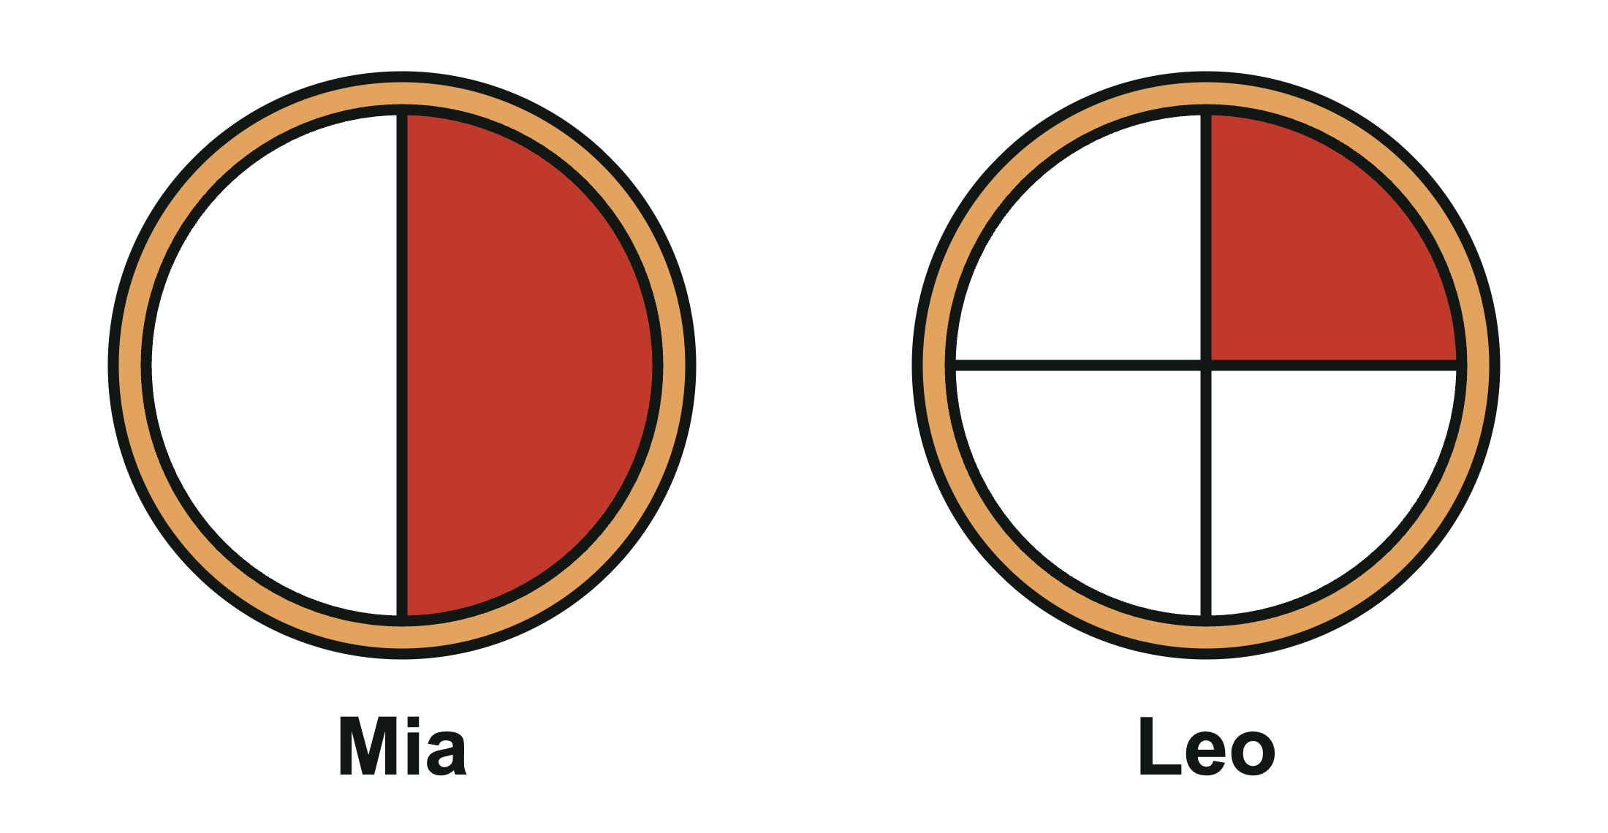
A. Leo B. Mia

Part 3: Shade and show
7. Shade each pie to show the order under it.
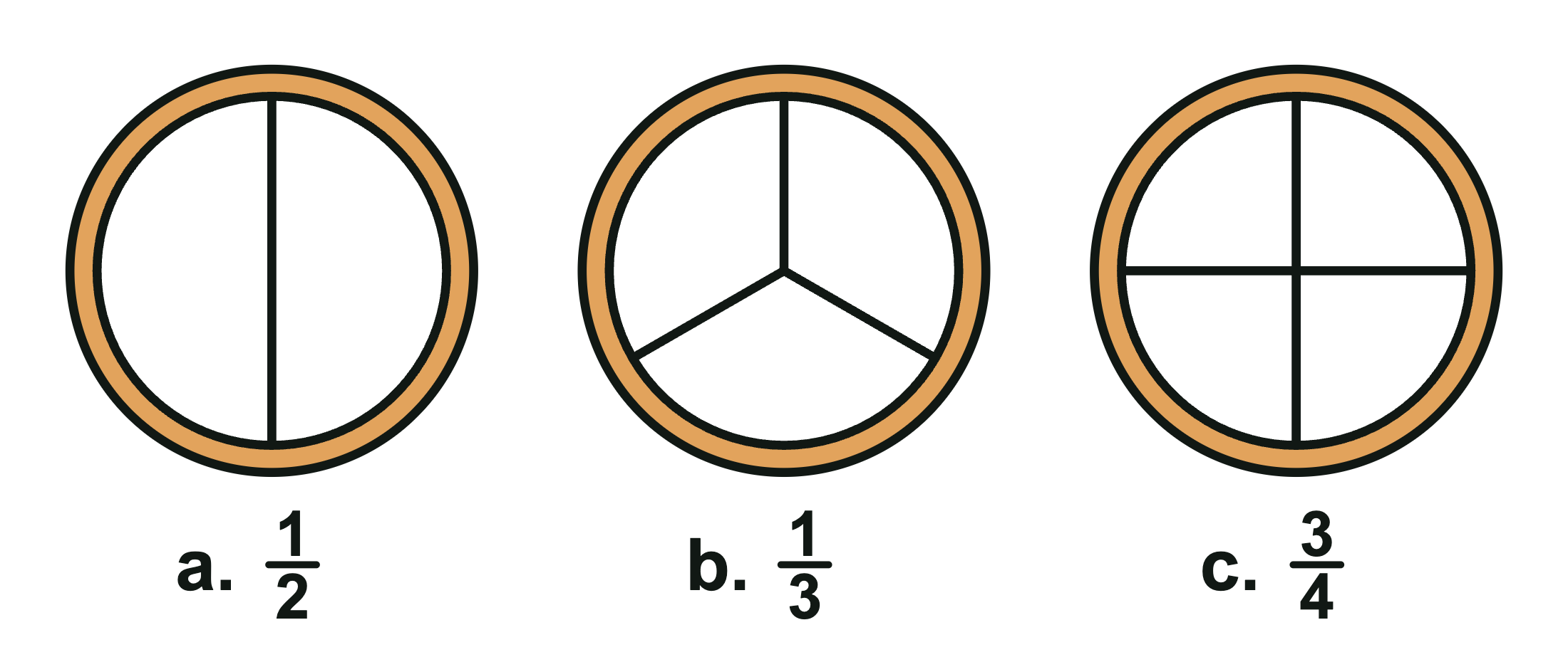
8. Zoe wants 5/8 of a peach pie. Shade the slices you would serve.
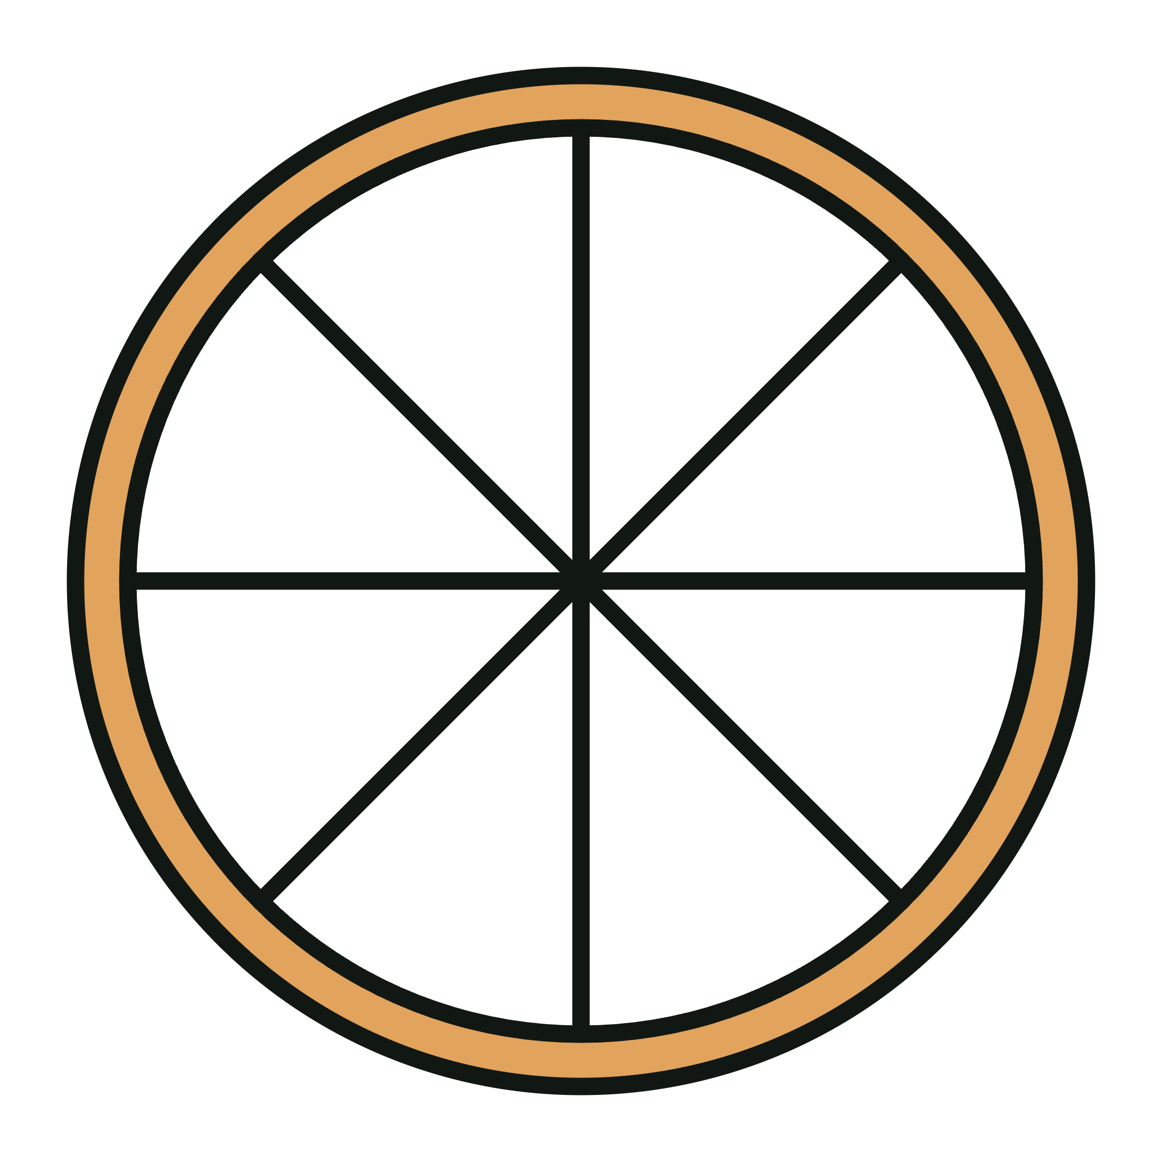

CEDAR HOLLOW SLICE SHOP · LEVEL 1: SUPPORT

Answer Key
Slice Shop: Fair Cuts and Orders

Part 1: Fair cuts
1. The pies are the same size. Which pie is cut into fourths?
B. Pie B
Pie B has 4 equal slices. Pie A has 4 slices, but they are not the same size. Pie C has 3 equal slices (thirds).
2. Grandpa Lou asked for thirds. This pie is cut into thirds.
False
The pie has 3 slices, but they are not the same size, so they are not thirds.

Part 2: Serve the order
3. Ava wants 3/4 of a cherry pie. The pie is cut into 4 equal slices. How many slices do you serve?
C. 3 slices
The pie has 4 equal slices, so each slice is 1/4. 3/4 is 3 slices.
4. Match each fraction to its name.
1/2: C. one half
1/3: B. one third
1/4: A. one fourth
5. A pie cut into 3 equal slices is cut into ____. A pie cut into 4 equal slices is cut into ____.
A pie cut into 3 equal slices is cut into thirds. A pie cut into 4 equal slices is cut into fourths.
6. Mia ordered 1/2 of a pie. Leo ordered 1/4 of a same-size pie. Who gets the bigger box?
B. Mia
Halves are bigger slices than fourths, so 1/2 > 1/4. Mia ordered more pie.

Part 3: Shade and show
7. Shade each pie to show the order under it.
Look for: a. 1 of the 2 equal slices is shaded. b. 1 of the 3 equal slices is shaded. c. 3 of the 4 equal slices are shaded. Any slices may be chosen.
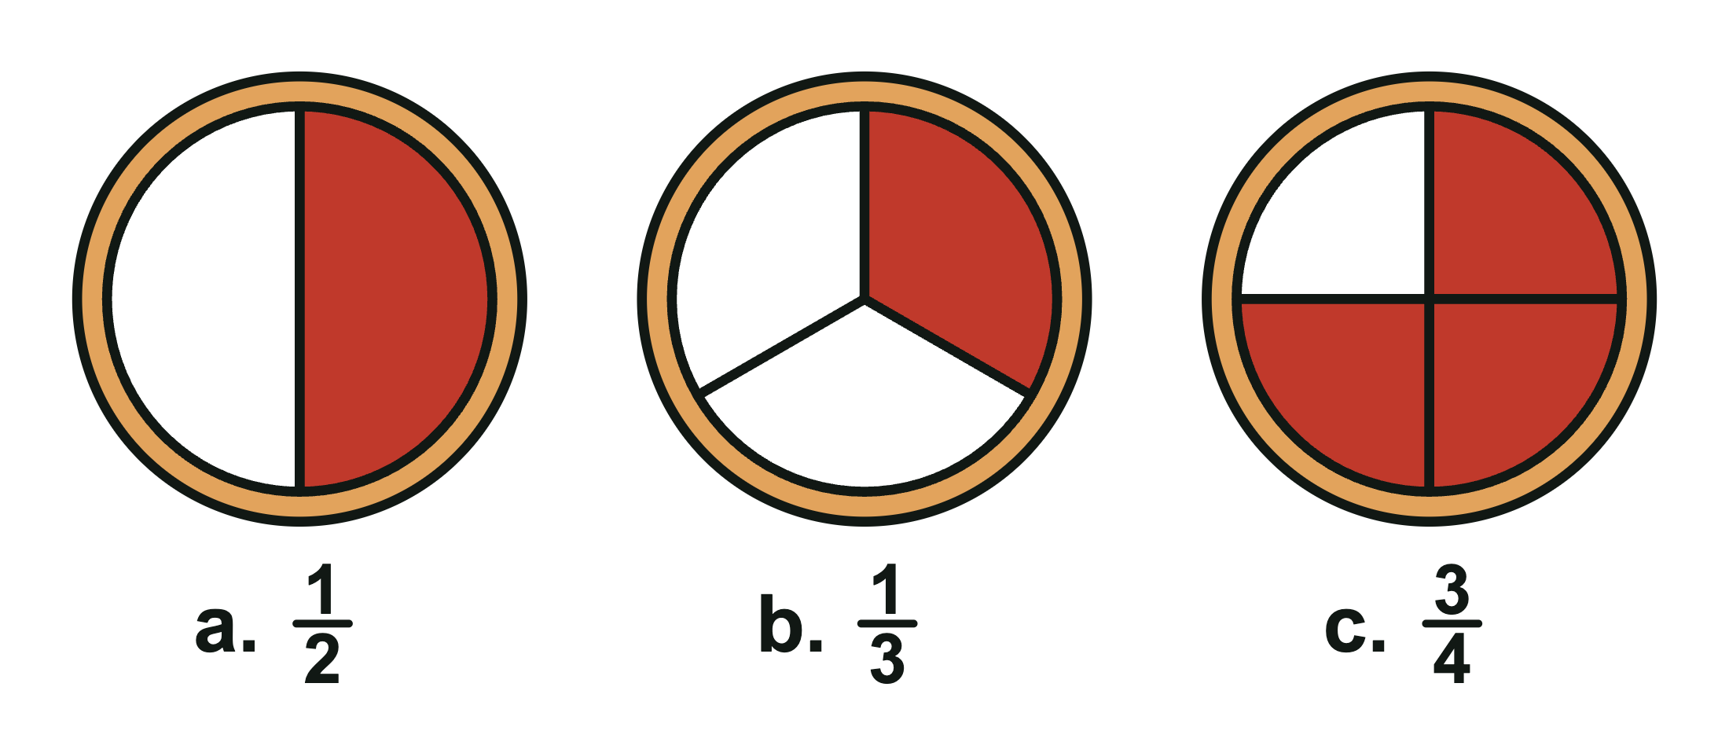
8. Zoe wants 5/8 of a peach pie. Shade the slices you would serve.
Look for: Any 5 of the 8 equal slices are shaded.
