Name __________________________________ Date ________________
CEDAR HOLLOW CASE FILES · LEVEL 3: CHALLENGE

Case File: The Missing Bake Sale Bell (Challenge)
Read closely. Explain your thinking with evidence from each passage, the way you did on the case board.

Part 1: Weather Watch
1. Read the Weather Watch story. What mood do the phrases "lightning stabbed at the hills" and "the wind grabbed its branches" help create?
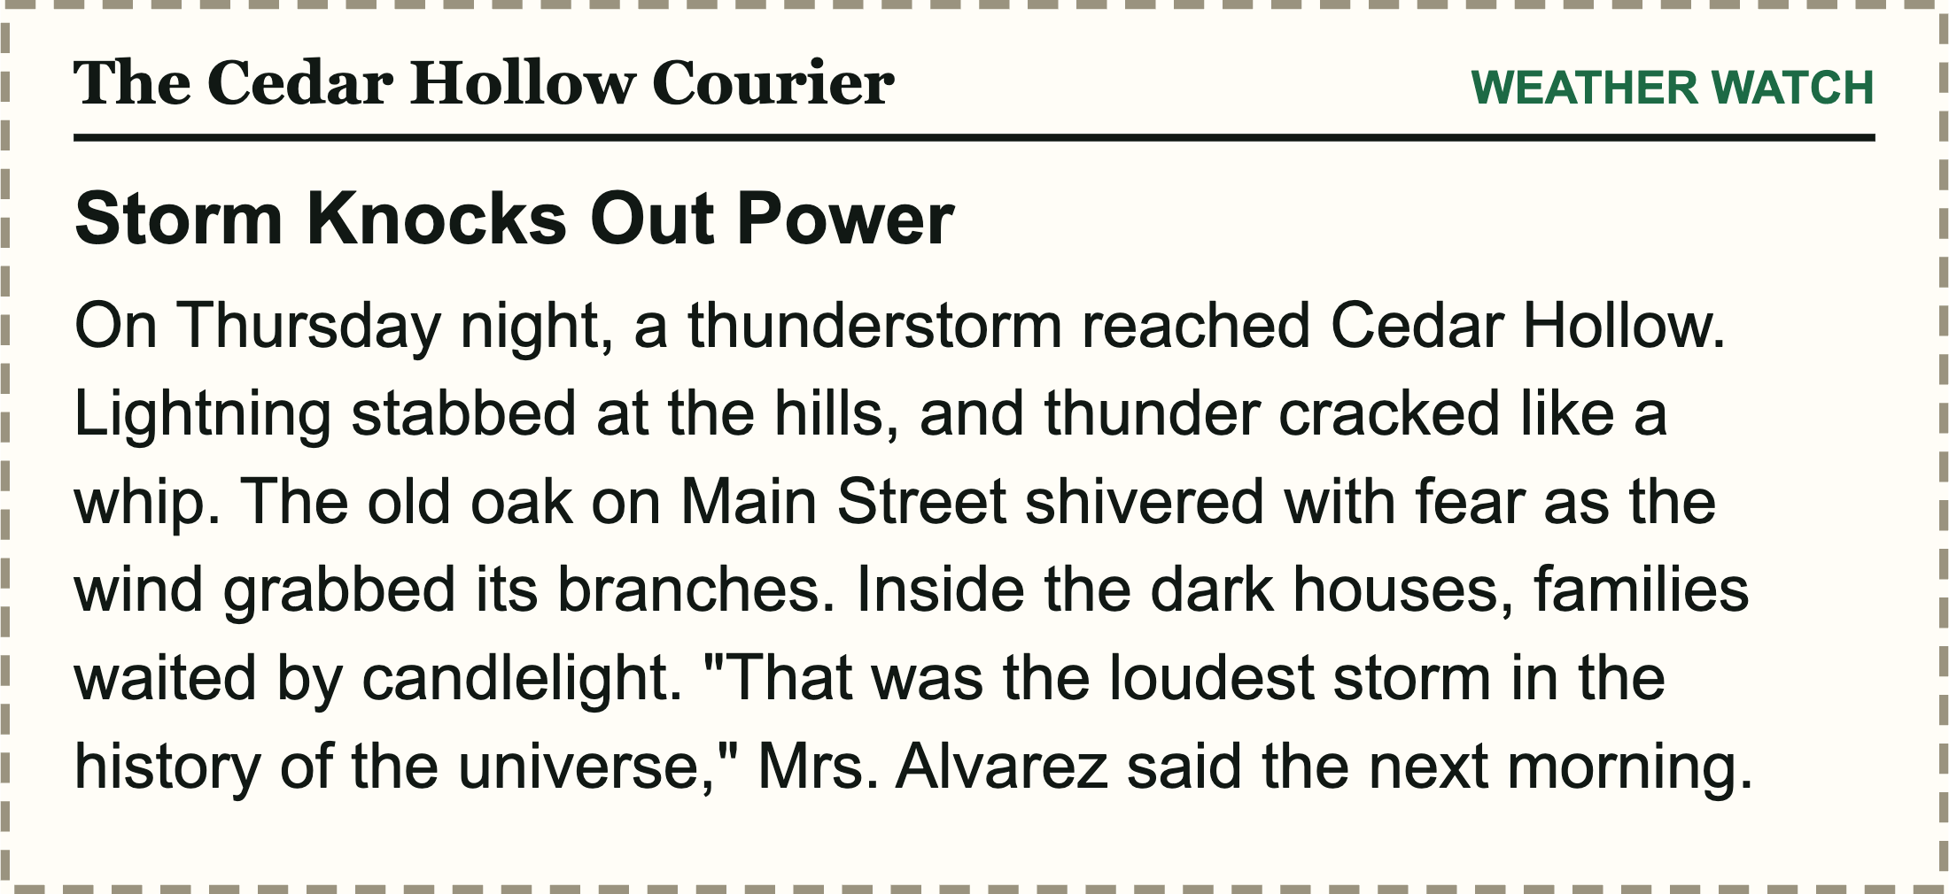
A. Cozy and safe
B. Tense and frightening
C. Silly and playful
D. Bored and sleepy
2. In the story, the old oak "shivered with fear." Name the kind of figurative language. Why did the writer choose it instead of a literal sentence like "the oak moved in the wind"?

3. Mrs. Alvarez says it was "the loudest storm in the history of the universe." Which choice correctly names the device AND its purpose?
A. Simile, to compare the storm to the universe
B. Literal language, to report a scientific fact
C. Hyperbole, to show how loud and frightening the storm felt to her
D. Idiom, to say the storm was ordinary
4. Rewrite "Lightning stabbed at the hills" so the storm feels calm or beautiful instead of tense. Use figurative language and name the kind you used.

Part 2: Tricky notes and meaning
5. Three of these notes are figurative. Which note is literal, even though it uses the word like?
A. The crowd buzzed like a hive of bees.
B. Mayor Diaz would like the stage swept by noon.
C. Rain fell like a curtain of silver threads.
D. The trophy shone like a mirror.
6. Around Town: At the science fair, Nadia's wind turbine was a magnet for visitors. A crowd stood at her table all afternoon. What is the BEST interpretation of the metaphor?
A. It drew many people.
B. It was made of metal.
C. Visitors got stuck to it.
D. It pushed people away.
7. Sports: Aiyana's knee was sore, but she bit the bullet and finished the last drill. What does the idiom mean here?
A. She chewed on metal.
B. She quit early.
C. She argued with her coach.
D. She kept going despite the pain.
8. Sort each sentence by the mood it creates.
Items to sort: The kettle sang softly on the stove. Shadows crept across the empty gym. Mia's quilt wrapped around her like a warm hug. Rain hammered the windows like angry fists.

Cozy and calm | Tense and stormy

9. Changing "the breeze whispered" to "the wind shrieked" makes the mood more tense.
True False
Circle one.

Part 3: Decode the lead
10. A witness says the bell-taker "still had to learn the ropes of fixing old bells." Name the device, decode what it really means, and explain which kind of place a detective should check next and why.

CEDAR HOLLOW CASE FILES · LEVEL 3: CHALLENGE

Answer Key
Case File: The Missing Bake Sale Bell (Challenge)

Part 1: Weather Watch
1. Read the Weather Watch story. What mood do the phrases "lightning stabbed at the hills" and "the wind grabbed its branches" help create?
B. Tense and frightening
Stabbing and grabbing are violent human actions, so the storm feels dangerous.
2. In the story, the old oak "shivered with fear." Name the kind of figurative language. Why did the writer choose it instead of a literal sentence like "the oak moved in the wind"?
Sample answer: Personification: a tree cannot feel fear. The human feeling makes the storm seem scary and builds a tense mood, while the literal sentence only reports movement.
3. Mrs. Alvarez says it was "the loudest storm in the history of the universe." Which choice correctly names the device AND its purpose?
C. Hyperbole, to show how loud and frightening the storm felt to her
She is exaggerating, not stating a fact, and there is no like or as. The hyperbole shows how scary the storm felt.
4. Rewrite "Lightning stabbed at the hills" so the storm feels calm or beautiful instead of tense. Use figurative language and name the kind you used.
Sample answer: Lightning flickered over the hills like distant fireflies. (simile) Accept any correctly named device that creates a calm or beautiful mood.

Part 2: Tricky notes and meaning
5. Three of these notes are figurative. Which note is literal, even though it uses the word like?
B. Mayor Diaz would like the stage swept by noon.
Here like means want, so nothing is being compared. The other three use like to compare two different things, so they are similes.
6. Around Town: At the science fair, Nadia's wind turbine was a magnet for visitors. A crowd stood at her table all afternoon. What is the BEST interpretation of the metaphor?
A. It drew many people.
A magnet pulls things toward it; the crowd is the context clue.
7. Sports: Aiyana's knee was sore, but she bit the bullet and finished the last drill. What does the idiom mean here?
D. She kept going despite the pain.
To bite the bullet means to face something hard bravely; she finished on a sore knee.
8. Sort each sentence by the mood it creates.
Cozy and calm | Tense and stormy
The kettle sang softly on the stove. | Shadows crept across the empty gym.
Mia's quilt wrapped around her like a warm hug. | Rain hammered the windows like angry fists.
Soft singing and a warm hug feel safe; creeping shadows and angry fists feel threatening.
9. Changing "the breeze whispered" to "the wind shrieked" makes the mood more tense.
True
Both are personification, but shrieked suggests fear while whispered feels gentle.

Part 3: Decode the lead
10. A witness says the bell-taker "still had to learn the ropes of fixing old bells." Name the device, decode what it really means, and explain which kind of place a detective should check next and why.
Sample answer: Idiom. To learn the ropes means to learn how to do a job, so the bell-taker did not know how to fix bells yet. A detective should check a place where she could learn, such as the library (to read about it) or a repair shop (to ask an expert). Accept any place that fits learning how, supported by the meaning; a hardware store for buying rope is the literal misreading.

