Name __________________________________ Date ________________
CEDAR HOLLOW CASE FILES · LEVEL 2: ON LEVEL

Case File: The Missing Bake Sale Bell (On Level)
Someone borrowed the bake sale bell. Use the four detective questions: Literally true? Clue? Meaning? Why? Then decode each lead.

Part 1: Around Town witness report
1. Read the Around Town story. Then write each phrase from the story under the kind of figurative language it uses.
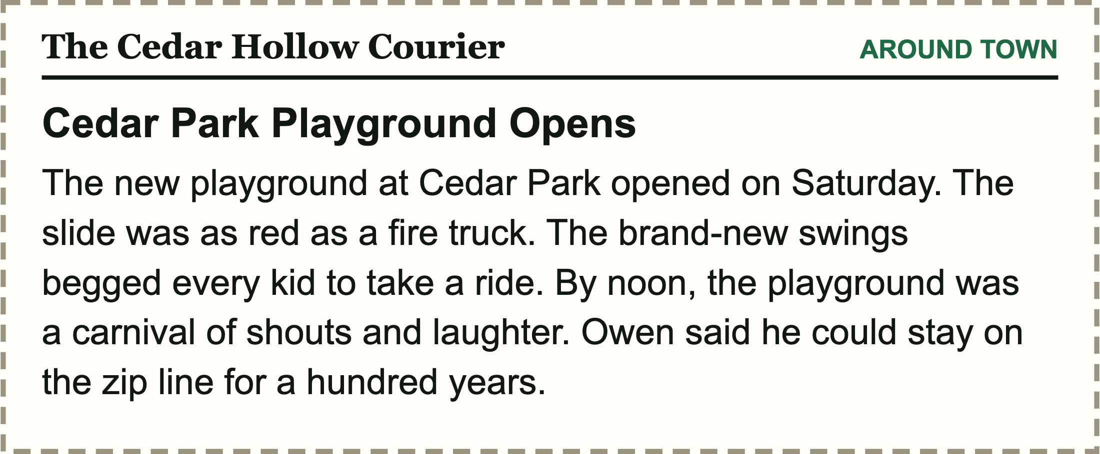
Items to sort: as red as a fire truck the swings begged every kid to take a ride the playground was a carnival of shouts and laughter stay on the zip line for a hundred years

Simile | Metaphor | Personification | Hyperbole

2. In the story, the playground "was a carnival of shouts and laughter." What does this metaphor tell readers about opening day?

3. Why does the writer include Owen's words about the zip line?
A. To give an exact time
B. To show how much Owen loved it
C. To say the zip line broke
D. To compare Owen to a bird

Part 2: Find the note and decode the leads
4. The bell-taker always writes in figurative language. Which note did the bell-taker leave?
A. The bake sale starts at noon.
B. Please return the cones to the gym.
C. This old bell is begging for a polish.
D. The library closes at 5 p.m.
5. Witnesses used these idioms. Match each idiom to what it really means. One meaning is extra.
Write the letter of the match on each line.
______ | hit the hay |  | A. go to sleep
______ | once in a blue moon |  | B. wait patiently
______ | keep an eye on |  | C. feel very cold
______ | sit tight |  | D. watch carefully
 |  |  | E. very rarely

6. Jamal forgot to return his library book three weeks in a row, so now he is ________________ with the librarian.
Word bank: in hot water break a leg hit the hay
7. Mrs. Haddad says the bell-taker had "a million questions about cleaning brass" to look up. Where should a detective go next?
A. The bank, because she needed a million dollars
B. The library, because she had many questions to research
C. The post office, because she wanted to mail a million letters

Part 3: Check and write
8. "The alarm clock screamed at 6 a.m." uses personification, because screaming is something people do.
True False
Circle one.
9. Turn this literal Courier sentence into a simile: "The marching band was loud."

CEDAR HOLLOW CASE FILES · LEVEL 2: ON LEVEL

Answer Key
Case File: The Missing Bake Sale Bell (On Level)

Part 1: Around Town witness report
1. Read the Around Town story. Then write each phrase from the story under the kind of figurative language it uses.
Simile | Metaphor | Personification | Hyperbole
as red as a fire truck | the playground was a carnival of shouts and laughter | the swings begged every kid to take a ride | stay on the zip line for a hundred years
As red as a fire truck uses as, so it is a simile. Swings cannot beg, so that is personification. The playground was a carnival says one thing was another, so it is a metaphor. A hundred years on a zip line is an impossible exaggeration, so it is hyperbole.
2. In the story, the playground "was a carnival of shouts and laughter." What does this metaphor tell readers about opening day?
Sample answer: It tells readers the playground was busy, noisy, and full of happy kids having fun, the way a carnival is crowded and exciting.
3. Why does the writer include Owen's words about the zip line?
B. To show how much Owen loved it
No one could stay on a zip line for a hundred years. The hyperbole emphasizes how much fun Owen had.

Part 2: Find the note and decode the leads
4. The bell-taker always writes in figurative language. Which note did the bell-taker leave?
C. This old bell is begging for a polish.
A bell cannot beg, so that note uses personification. The other three notes mean exactly what they say.
5. Witnesses used these idioms. Match each idiom to what it really means. One meaning is extra.
hit the hay: A. go to sleep
once in a blue moon: E. very rarely
keep an eye on: D. watch carefully
sit tight: B. wait patiently
6. Jamal forgot to return his library book three weeks in a row, so now he is ____ with the librarian.
Jamal forgot to return his library book three weeks in a row, so now he is in hot water with the librarian.
In hot water is an idiom that means in trouble. The other two do not fit the sentence.
7. Mrs. Haddad says the bell-taker had "a million questions about cleaning brass" to look up. Where should a detective go next?
B. The library, because she had many questions to research
A million questions is hyperbole for a lot of questions. The place to research questions is the library.

Part 3: Check and write
8. "The alarm clock screamed at 6 a.m." uses personification, because screaming is something people do.
True
9. Turn this literal Courier sentence into a simile: "The marching band was loud."
Sample answer: The marching band was as loud as a thunderstorm. (Any sentence that uses like or as to compare the band to a different kind of thing is correct.)

