Name __________________________________ Date ________________
CEDAR HOLLOW CASE FILES · LEVEL 1: SUPPORT

Case File: The Missing Bake Sale Bell (Support)
Someone borrowed the bake sale bell, and every clue uses figurative language. Ask: could this really be true? Use the Detective Clue Cards and the word bank to help you.

Part 1: Find the clue notes
1. Six notes were found at the bake sale. Write each one under Literal (means exactly what it says) or Figurative (means something more).
Items to sort: The library closes at 5 p.m. The soup was as smooth as velvet. Ravi rode his bike to school. The flowers waved hello to the bees. Snow fell on Tuesday night. Nadia has a million friends.

Literal | Figurative

Part 2: Name it
2. A witness says, "The pancakes were as fluffy as clouds." What kind of figurative language is in bold?
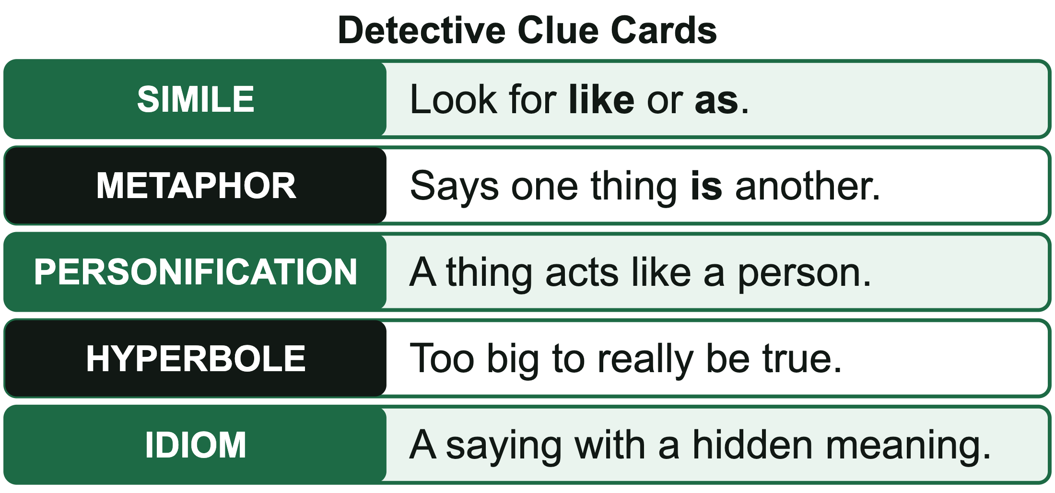
A. Simile B. Hyperbole C. Idiom
3. A witness says, "Jamal told me he was going to hit the hay early." What kind is in bold?
A. Simile B. Idiom C. Personification
4. A witness says, "The moon peeked out from behind the clouds." What kind is in bold?
A. Personification B. Simile C. Idiom

Part 3: Decode the lead
5. A witness says the bell-taker told her, "My stomach is as empty as a cave." What does that really mean, and where should a detective look next?
A. She was very hungry, so look at the cafe.
B. She wanted to explore a cave, so look at the hiking trail.
C. Her stomach hurt, so look at the pharmacy.
6. At the cafe, the bell-taker told the band, "Break a leg!" What did she really mean?
A. Hurt yourself B. Good luck C. Play louder
7. Her last note says, "The hallway was a river of backpacks." It is a ________________ because it says the hallway ________________ a river.
Word bank: simile metaphor like was
8. It's raining cats and dogs means it is raining very hard. Draw what the words literally say. Then write what the idiom really means.

CEDAR HOLLOW CASE FILES · LEVEL 1: SUPPORT

Answer Key
Case File: The Missing Bake Sale Bell (Support)

Part 1: Find the clue notes
1. Six notes were found at the bake sale. Write each one under Literal (means exactly what it says) or Figurative (means something more).
Literal | Figurative
The library closes at 5 p.m. | The soup was as smooth as velvet.
Ravi rode his bike to school. | The flowers waved hello to the bees.
Snow fell on Tuesday night. | Nadia has a million friends.
The literal notes are plain facts. The figurative ones are a simile (as smooth as velvet), personification (flowers cannot wave), and hyperbole (a million friends).

Part 2: Name it
2. A witness says, "The pancakes were as fluffy as clouds." What kind of figurative language is in bold?
A. Simile
The word as compares the pancakes to clouds, two different kinds of things.
3. A witness says, "Jamal told me he was going to hit the hay early." What kind is in bold?
B. Idiom
Hit the hay is a common saying that means go to bed. Nobody is hitting any hay.
4. A witness says, "The moon peeked out from behind the clouds." What kind is in bold?
A. Personification
Peeking is something a person does. The moon cannot really peek.

Part 3: Decode the lead
5. A witness says the bell-taker told her, "My stomach is as empty as a cave." What does that really mean, and where should a detective look next?
A. She was very hungry, so look at the cafe.
A cave is hollow and empty. An empty stomach means she was hungry, so she went somewhere to eat.
6. At the cafe, the bell-taker told the band, "Break a leg!" What did she really mean?
B. Good luck
Break a leg is a common saying that means good luck, often said before a concert or a play.
7. Her last note says, "The hallway was a river of backpacks." It is a ____ because it says the hallway ____ a river.
Her last note says, "The hallway was a river of backpacks." It is a metaphor because it says the hallway was a river.
8. It's raining cats and dogs means it is raining very hard. Draw what the words literally say. Then write what the idiom really means.
Look for: The picture shows cats and dogs falling from the sky (the literal words). The written meaning says it is raining very hard.

