Name __________________________________ Date ________________
CHECKS AND BALANCES · LEVEL 2: ON LEVEL

Checks and Balances: On Level Practice
Answer each question. Use complete sentences for written answers. Article and Section numbers refer to the U.S. Constitution. Every vote says all members are present and vote.

Part 1: From bill to law
1. The House and the Senate pass different versions of the same bill. What must happen before it can go to the President?
A. The President picks one version
B. The version with more yes votes goes forward
C. Both chambers pass one identical version
D. The Supreme Court picks one version
2. The President does not sign or return a bill. Ten days pass (Sundays excepted), and Congress is still in session. What happens?
A. It becomes law without the President's signature
B. It is vetoed automatically
C. It goes back to committee
D. It waits until the President signs it
3. A vetoed bill goes back to the chamber where it ________________. Bills for raising revenue (taxes) must start in the ________________.
4. Override votes. Every member is present and votes. Did the override reach two-thirds in that chamber? (House: 290 of 435. Senate: 67 of 100.)
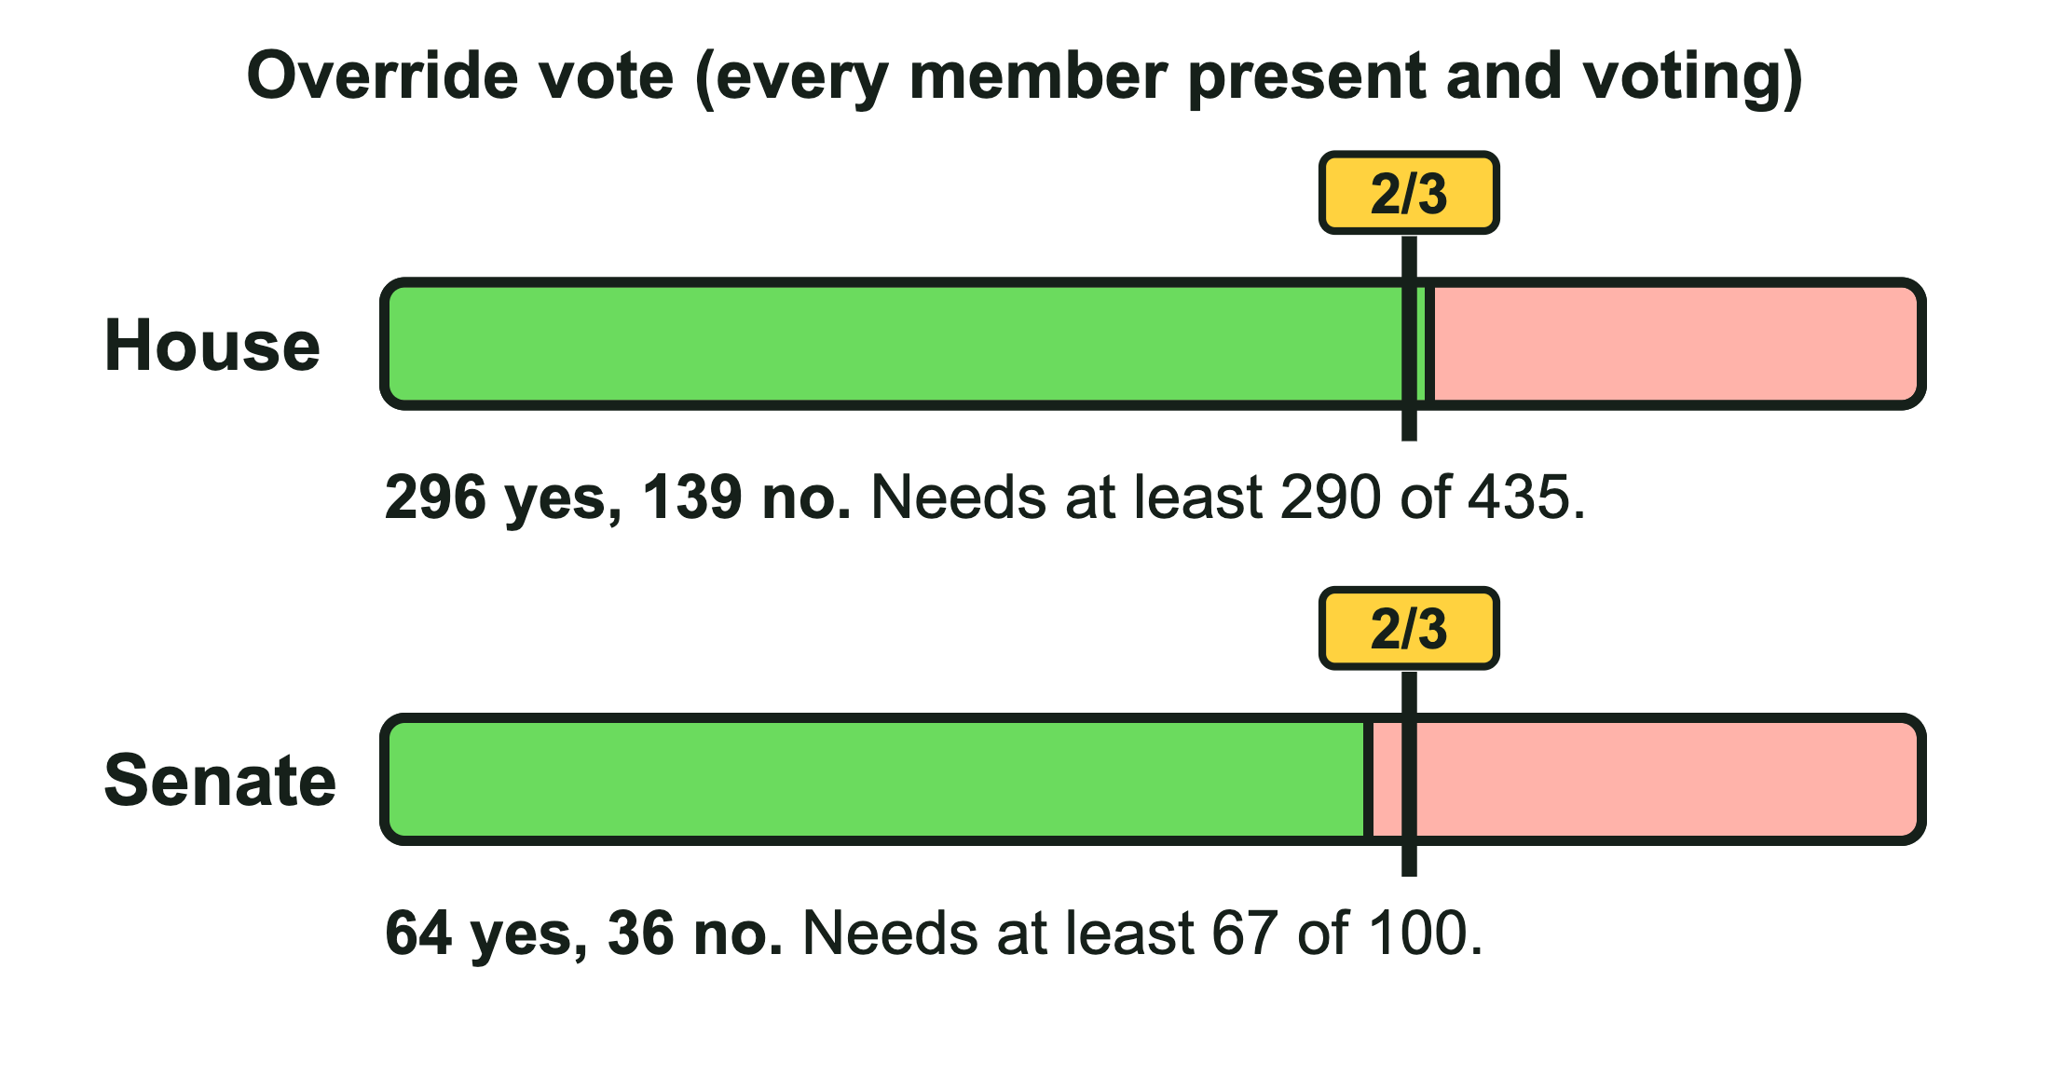
Items to sort: House: 312 yes, 123 no House: 268 yes, 167 no Senate: 70 yes, 30 no Senate: 59 yes, 41 no House: 296 yes, 139 no Senate: 64 yes, 36 no

Reached two-thirds | Fell short

Part 2: Checks between the branches
5. Sort each check by the branch that uses it.
Items to sort: Overrides a veto Vetoes a bill Declares a law unconstitutional Confirms or rejects federal judges Nominates federal judges Rules an executive order unconstitutional

Legislative | Executive | Judicial

6. The ________________ has the sole power of impeachment. The ________________ tries all impeachments, and conviction takes ________________ of the senators present.
7. A newspaper editor sues, saying part of a federal law breaks the First Amendment. Can the editor file the case directly in the Supreme Court?
A. Yes, every federal case starts there
B. Yes, if Congress votes to send it there
C. No, courts cannot hear cases about federal laws
D. No, it starts in a lower court, and the Supreme Court can hear it on appeal
8. Explain how the veto checks Congress and how the override checks the President.

CHECKS AND BALANCES · LEVEL 2: ON LEVEL

Answer Key
Checks and Balances: On Level Practice

Part 1: From bill to law
1. The House and the Senate pass different versions of the same bill. What must happen before it can go to the President?
C. Both chambers pass one identical version
Article I, Section 7: a bill must pass both chambers before it is presented to the President, so both must pass the same words.
2. The President does not sign or return a bill. Ten days pass (Sundays excepted), and Congress is still in session. What happens?
A. It becomes law without the President's signature
Article I, Section 7.
3. A vetoed bill goes back to the chamber where it ____. Bills for raising revenue (taxes) must start in the ____.
A vetoed bill goes back to the chamber where it started. Bills for raising revenue (taxes) must start in the House of Representatives.
Article I, Section 7. Accept "originated" for the first blank and "House" for the second.
4. Override votes. Every member is present and votes. Did the override reach two-thirds in that chamber? (House: 290 of 435. Senate: 67 of 100.)
Reached two-thirds | Fell short
House: 312 yes, 123 no | House: 268 yes, 167 no
Senate: 70 yes, 30 no | Senate: 59 yes, 41 no
House: 296 yes, 139 no | Senate: 64 yes, 36 no
Article I, Section 7. The picture shows the last House and Senate tallies.

Part 2: Checks between the branches
5. Sort each check by the branch that uses it.
Legislative | Executive | Judicial
Overrides a veto | Vetoes a bill | Declares a law unconstitutional
Confirms or rejects federal judges | Nominates federal judges | Rules an executive order unconstitutional
The Senate (part of Congress) confirms or rejects judges.
6. The ____ has the sole power of impeachment. The ____ tries all impeachments, and conviction takes ____ of the senators present.
The House of Representatives has the sole power of impeachment. The Senate tries all impeachments, and conviction takes two-thirds of the senators present.
Article I, Section 2 (House) and Article I, Section 3 (Senate). Accept House for the first blank. A convicted official is removed from office.
7. A newspaper editor sues, saying part of a federal law breaks the First Amendment. Can the editor file the case directly in the Supreme Court?
D. No, it starts in a lower court, and the Supreme Court can hear it on appeal
Article III, Section 2: the Supreme Court hears cases first only when they affect ambassadors or a state is a party.
8. Explain how the veto checks Congress and how the override checks the President.
Sample answer: The veto lets the President block a bill Congress passed, and because an override needs two-thirds of both chambers (not just a majority), the veto is hard to undo. The override means the President cannot block a bill that has very broad support in Congress: if two-thirds of each chamber agree, it becomes law anyway.

