Name __________________________________ Date ________________
CHECKS AND BALANCES · LEVEL 1: SUPPORT

Checks and Balances: Support Practice
Read each question. Use the pictures and the word banks to help you. Article numbers refer to the U.S. Constitution. Every vote says all members are present and vote.

Part 1: Moving a bill
1. Match each article and branch to its main job.
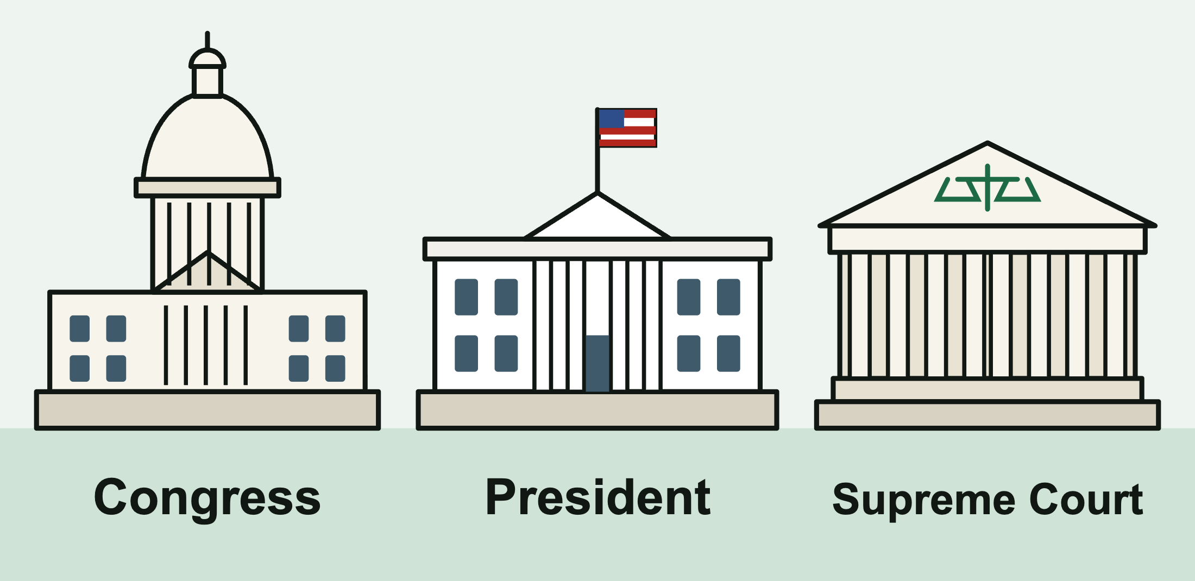
Write the letter of the match on each line.
______ | Article I: Congress |  | A. interprets the laws
______ | Article II: the President |  | B. carries out the laws
______ | Article III: the federal courts |  | C. makes the laws

2. The House just passed a bill. Where does the bill go next?
A. The President
B. The Senate
C. The Supreme Court
3. This cartoon shows a bill the President refused to sign and sent back to Congress. What is this action called?
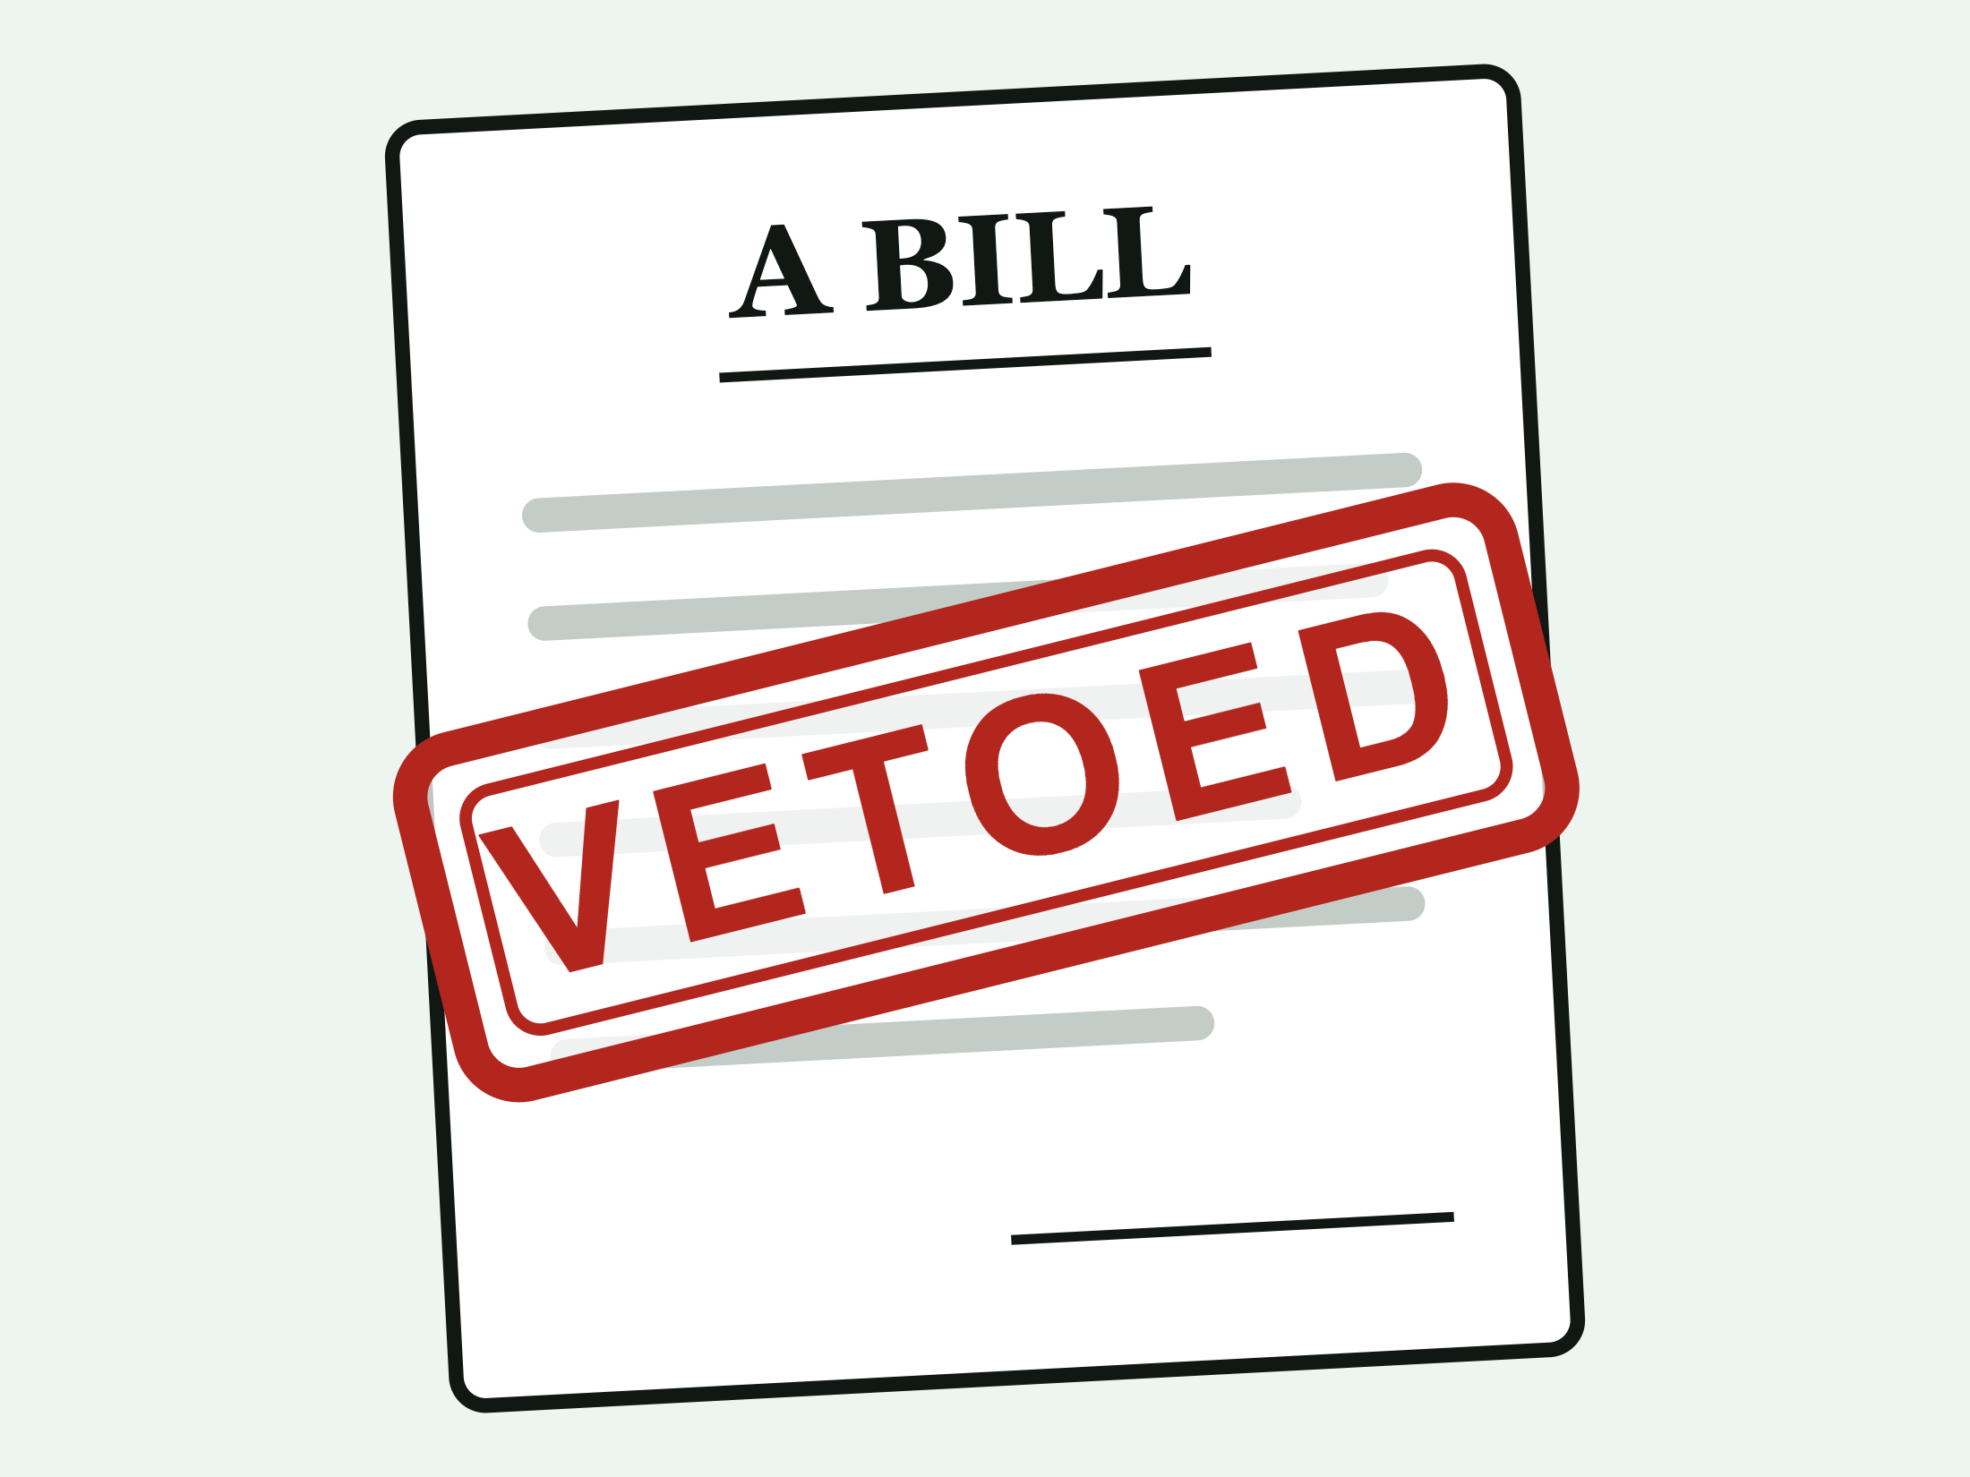
A. A veto B. An override C. An impeachment
4. The President vetoed a bill. Congress still wants it to become law. What can Congress do?
A. Ask the Supreme Court to sign it
B. Pass it again with just over half the votes
C. Override the veto with two-thirds of the House and two-thirds of the Senate
5. Congress votes to override a veto. The House votes 310 yes (it needs 290). The Senate votes 61 yes (it needs 67). The bill becomes law.
True False
Circle one.

Part 2: Checks
6. Sort each power into the branch that uses it.
Items to sort: Vetoes a bill Overrides a veto Strikes down an unconstitutional law Grants pardons Impeaches an official Decides court cases

Legislative (Congress) | Executive (President) | Judicial (courts)

7. When the House impeaches an official, the official is removed from office right away.
True False
Circle one.
8. The ________________ nominates a new Supreme Court justice, and the ________________ must confirm the nominee.
Word bank: President Senate House
9. A newspaper editor says a new law breaks the First Amendment and takes the case to court. Which branch decides whether the law follows the Constitution?
A. The legislative branch (Congress)
B. The judicial branch (the courts)
C. The executive branch (the President)

CHECKS AND BALANCES · LEVEL 1: SUPPORT

Answer Key
Checks and Balances: Support Practice

Part 1: Moving a bill
1. Match each article and branch to its main job.
Article I: Congress: C. makes the laws
Article II: the President: B. carries out the laws
Article III: the federal courts: A. interprets the laws
Congress is the legislative branch, the President leads the executive branch, and the federal courts are the judicial branch.
2. The House just passed a bill. Where does the bill go next?
B. The Senate
Article I, Section 7: a bill must pass both the House and the Senate before it goes to the President. Congress is bicameral.
3. This cartoon shows a bill the President refused to sign and sent back to Congress. What is this action called?
A. A veto
4. The President vetoed a bill. Congress still wants it to become law. What can Congress do?
C. Override the veto with two-thirds of the House and two-thirds of the Senate
Article I, Section 7.
5. Congress votes to override a veto. The House votes 310 yes (it needs 290). The Senate votes 61 yes (it needs 67). The bill becomes law.
False
The Senate fell short: 61 is less than 67. Both chambers must reach two-thirds, so the veto stands.

Part 2: Checks
6. Sort each power into the branch that uses it.
Legislative (Congress) | Executive (President) | Judicial (courts)
Overrides a veto | Vetoes a bill | Strikes down an unconstitutional law
Impeaches an official | Grants pardons | Decides court cases
Impeachment is done by the House, which is part of Congress.
7. When the House impeaches an official, the official is removed from office right away.
False
Impeach means to charge. The Senate holds a trial, and two-thirds of the senators present must vote to convict before the official is removed.
8. The ____ nominates a new Supreme Court justice, and the ____ must confirm the nominee.
The President nominates a new Supreme Court justice, and the Senate must confirm the nominee.
Article II, Section 2: the President nominates, with the advice and consent of the Senate.
9. A newspaper editor says a new law breaks the First Amendment and takes the case to court. Which branch decides whether the law follows the Constitution?
B. The judicial branch (the courts)
This power is called judicial review (Marbury v. Madison, 1803).

